

Lab Manual

DS-303
Data Mining

Submitted by

Muhammad Tayyab Imran 2023-BS-AI-019

Submitted to

Mr. Muhammad Arham

Department of Computer Science
Contents

Sr. No. | Lab No. | Topic | Page No.
1 | Lab-1 | KNIME Introduction | 1
2 | Lab-2 | Customer Churn Prediction | 6
3 | Lab-3 | Data Cleaning | 10
4 | Lab-4 | Data Preprocessing | 15
5 | Lab-5 | Market Basket Analysis | 19
6 | Lab-6 | Apriori Algorithm (Product Combination Analysis) | 24
7 | Lab-7 | FP-Growth (Efficient Frequent Pattern Mining) | 29
8 | Lab-8 | Python Basics (Reusable Data Processing Module) | 34
9 | Lab-9 | Decision Tree | 39
10 | Lab-10 | Naïve Bayes & KNN | 43
11 | Lab-11 | SVM | 48
12 | Lab-12 | Clustering | 53
13 | Lab-13 | Outlier Detection | 58
14 | Lab-14 | Scraping & Sentiment Analysis | 63
15 | Lab-15 | Final Capstone | 68

________________________________________________________
Lab 1: KNIME Introduction
________________________________________________________

Real-World Scenario
A retail company stores large volumes of transaction records across different product categories. Although the data is available, it cannot support decision-making unless it is organized and examined properly. Business managers require clear analytical outputs to measure overall sales revenue, estimate average customer purchase value, identify the categories generating the greatest earnings, and determine which individual products produce the highest profit contribution. This practical task uses KNIME Analytics Platform to transform raw retail sales data into useful business intelligence through a workflow-based analytical process.
Dataset Description
The dataset applied in this exercise is a Retail Sales CSV file containing detailed transaction records. Each row represents one completed sale and includes the following fields:
- Transaction ID
- Product Title
- Product Category
- Quantity Sold
- Unit Price
- Purchase Date
- Sales Amount (or Revenue generated during processing)
The dataset is suitable for performing summarization, revenue calculations, category comparisons, and product ranking analysis.
Software Tool Used — KNIME Analytics Platform
KNIME is a visual analytics software that allows users to create data workflows by connecting functional nodes. Every node is responsible for a specific task such as importing files, cleaning data, changing data types, calculating formulas, generating summaries, or performing aggregations. When combined, these nodes build a complete data analysis pipeline that converts unstructured sales records into valuable managerial insights.
Practical Learning Outcomes
1 | Load a CSV sales dataset into KNIME using the CSV Reader node.
2 | Inspect and adjust column data types for accurate processing.
3 | Produce descriptive statistics to understand the nature of the dataset.
4 | Create a new Revenue field using the Math Formula node.
5 | Analyze four major retail KPIs using GroupBy and Sorter nodes.

Procedure
1 | Import the Dataset

Use the CSV Reader node to load the Retail Sales dataset into the workflow environment and verify successful execution.
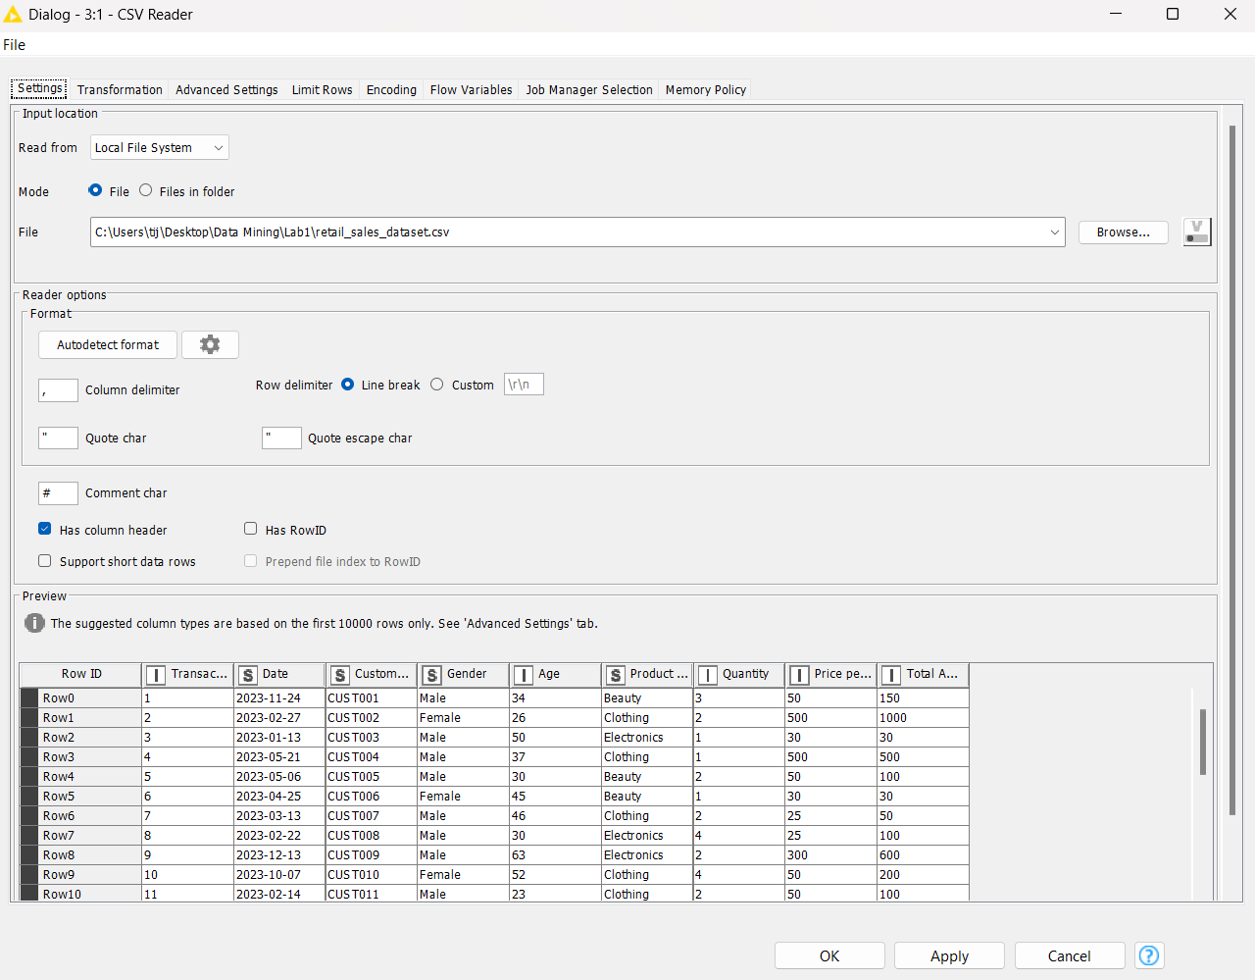

2 | Verify the Data Types

Inspect all columns to ensure numeric fields (Quantity, Price, Revenue) are correctly typed as Integer or Double, and categorical fields (Category, Product Name) are set as String.
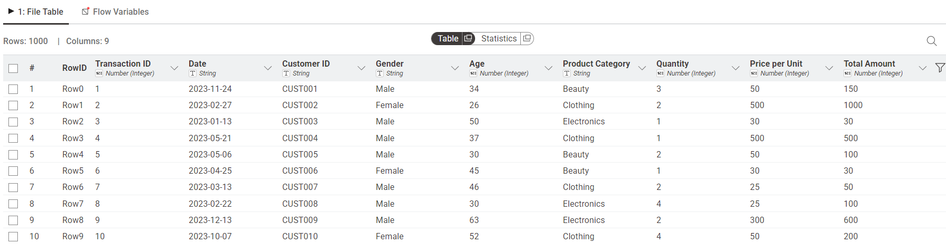

3 | Generate Summary Statistics

Apply the Statistics node to compute descriptive measures such as mean, minimum, maximum, sum, and standard deviation for numeric attributes.
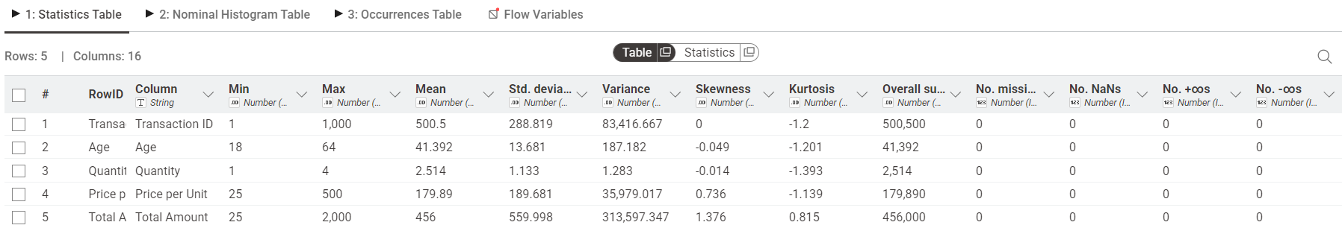

4 | Calculate Total Revenue (KPI 1)

Add a GroupBy node without selecting any grouping column and aggregate the Revenue column using the Sum function to compute overall sales revenue.
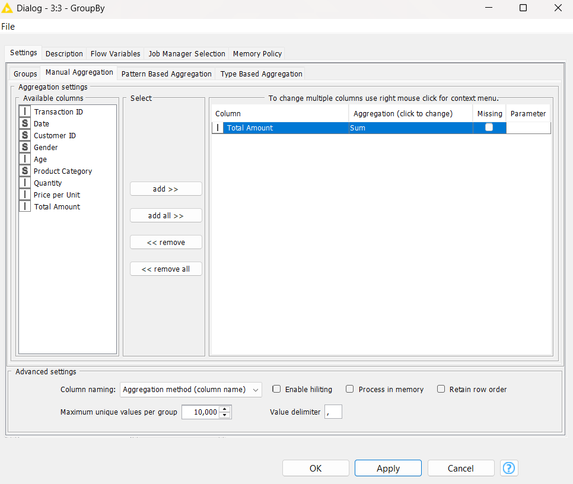
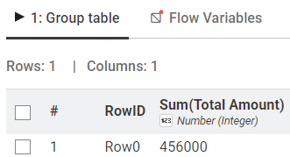

5 | Calculate Average Order Value (KPI 2)

Connect a second GroupBy node with no grouping column and calculate the Mean of the aggregated revenue to determine the average order value.
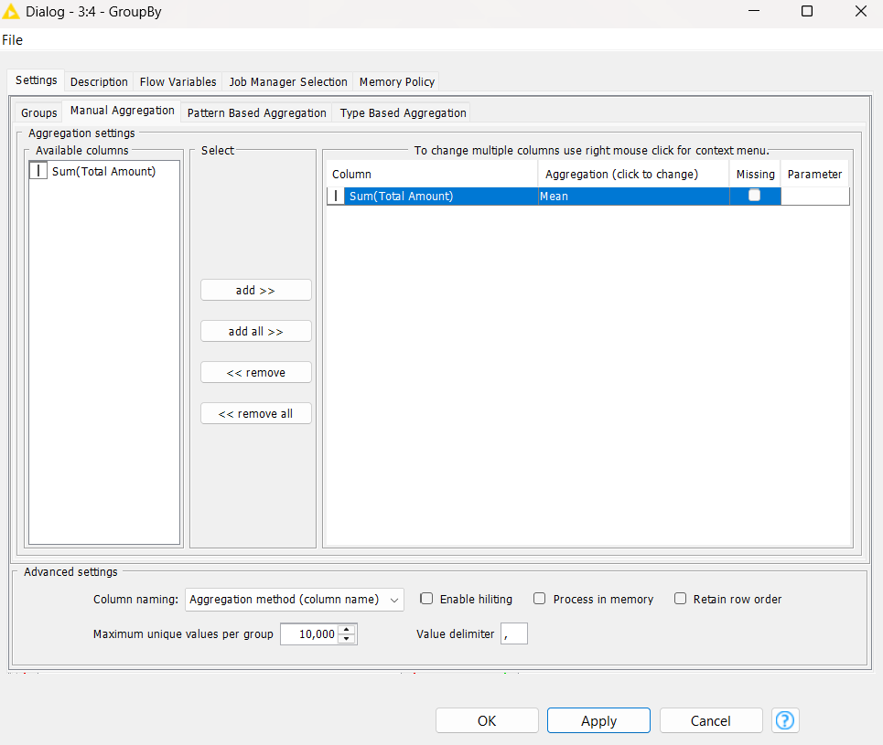
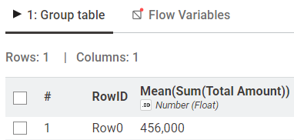

6 | Calculate Category Revenue (KPI 3)

Add a GroupBy node and group by Product Category. Aggregate Revenue using Sum to compute total earnings for each category.
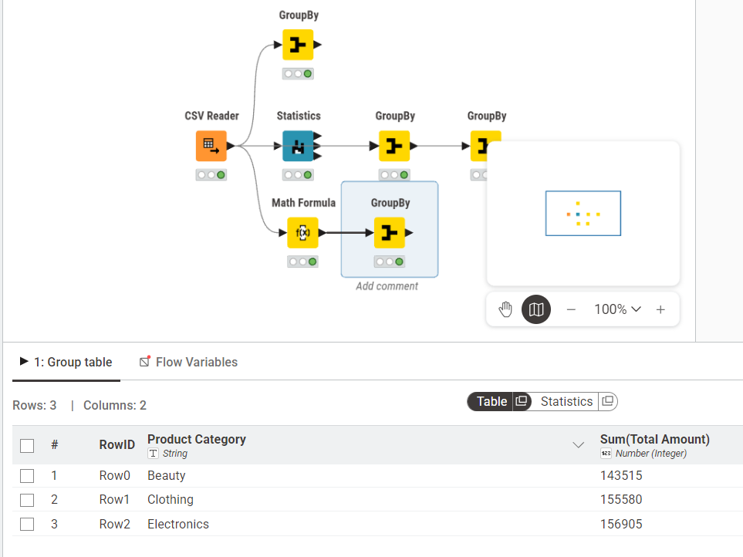

________________________________________________________
Lab 2: Customer Churn Prediction
________________________________________________________

Real-World Scenario
An e-commerce business aims to identify customers who are likely to discontinue using its services. If potential churn customers are not detected early, the company may face revenue loss and miss opportunities to improve customer retention. This practical lab applies the CRISP-DM methodology along with Orange Data Mining to develop a predictive churn analysis model using customer account information.
Dataset Description
The dataset used in this exercise is Churn_Modelling.csv, which contains 10,000 customer records with 14 attributes. The target column is Exited, where 1 = Customer Left (Churned) and 0 = Customer Stayed (Retained). Important input features include:
- Credit Score
- Geography
- Gender
- Age
- Tenure
- Account Balance
- Number of Products
- Credit Card Ownership
- Active Membership Status
- Estimated Salary
During preprocessing, unnecessary columns such as RowNumber, CustomerId, and Surname were excluded.
Software Environment — Orange Data Mining
Orange is a free and open-source visual data mining tool that allows users to create machine learning workflows by connecting widgets on a canvas. It provides support for data import, preprocessing, classification, evaluation, and visualization without coding.
Practical Objectives
1 | Import and inspect a CSV dataset using File and Data Table widgets.
2 | Remove unnecessary columns and assign the target variable using Select Columns.
3 | Normalize numerical data and encode categorical features using Preprocess.
4 | Train Logistic Regression and Random Forest classification models.
5 | Compare model performance using Test and Score with 10-fold cross-validation.
6 | Analyze results using Confusion Matrix and ROC Analysis.
7 | Compute important business KPIs such as Churn Rate and Retention Rate.

Procedure

1 | Load the Dataset

Use the File widget to load Churn_Modelling.csv and connect it to a Data Table widget to verify all 10,000 rows and 14 columns are loaded correctly.
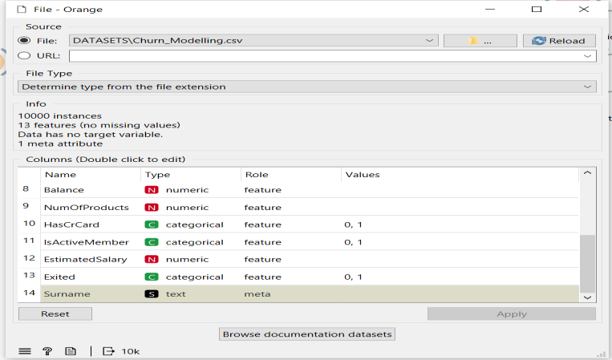

2 | Select Columns

Connect to a Select Columns widget. Move RowNumber, CustomerId, and Surname to the Ignore list. Set Exited as the Target class and keep all remaining features.
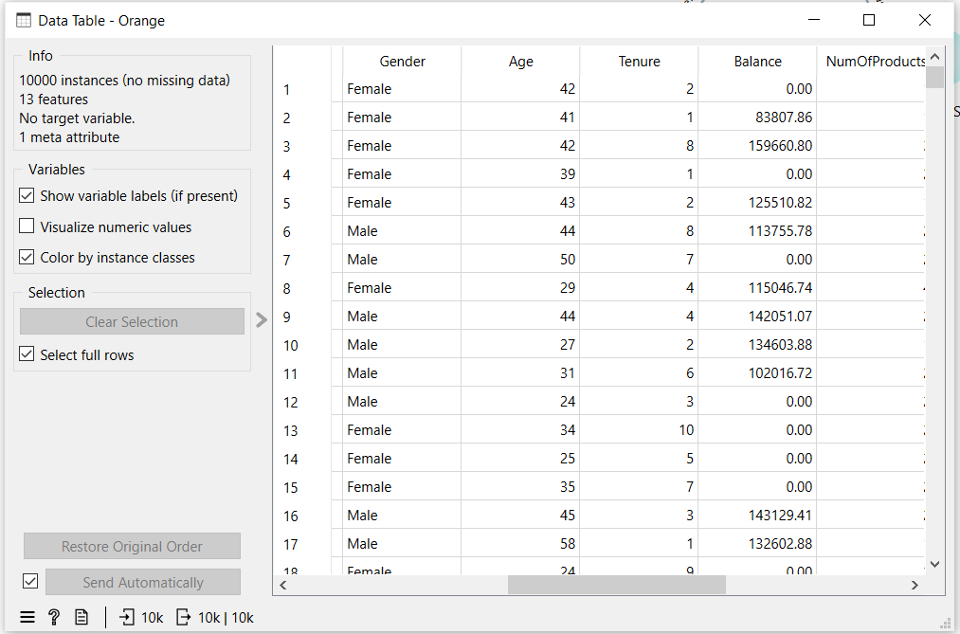

3 | Preprocess

Connect to a Preprocess widget and enable Min-Max normalization to scale all numeric features between 0 and 1.
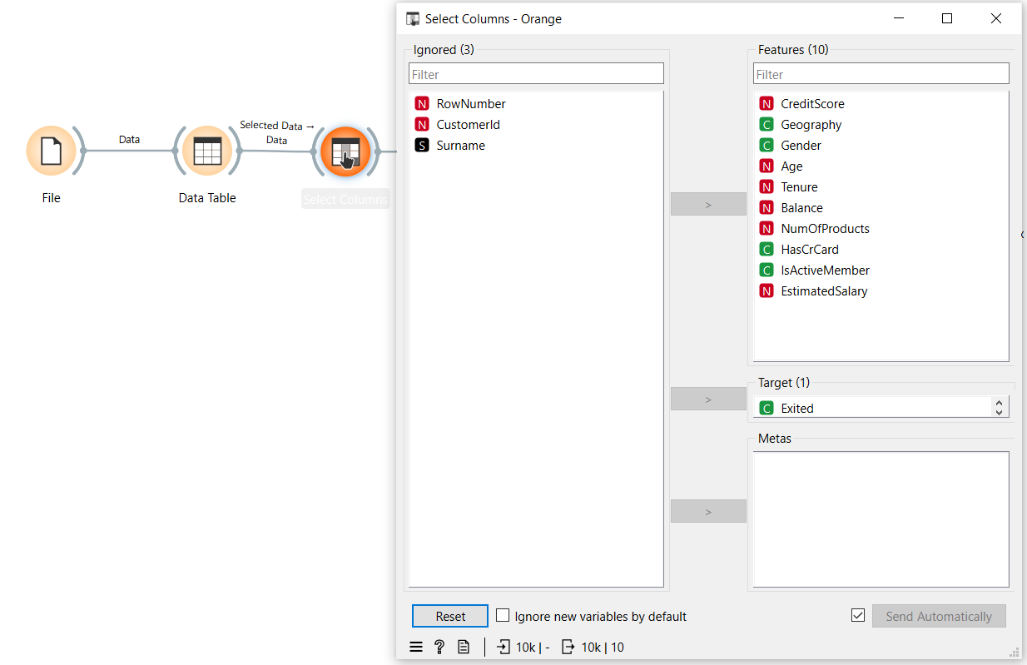

4 | Add Models

Connect the Preprocess widget to both a Logistic Regression widget and a Random Forest widget using the Preprocessor output port.
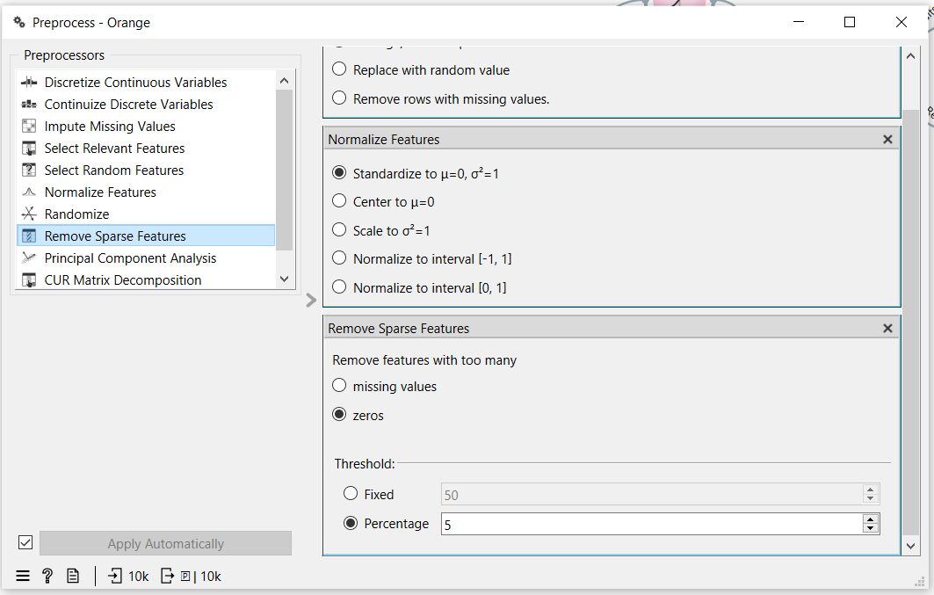

5 | Test and Score

Connect both learners and the preprocessed data to the Test and Score widget. Set evaluation to Cross Validation with 10 folds and enable Stratified splitting.
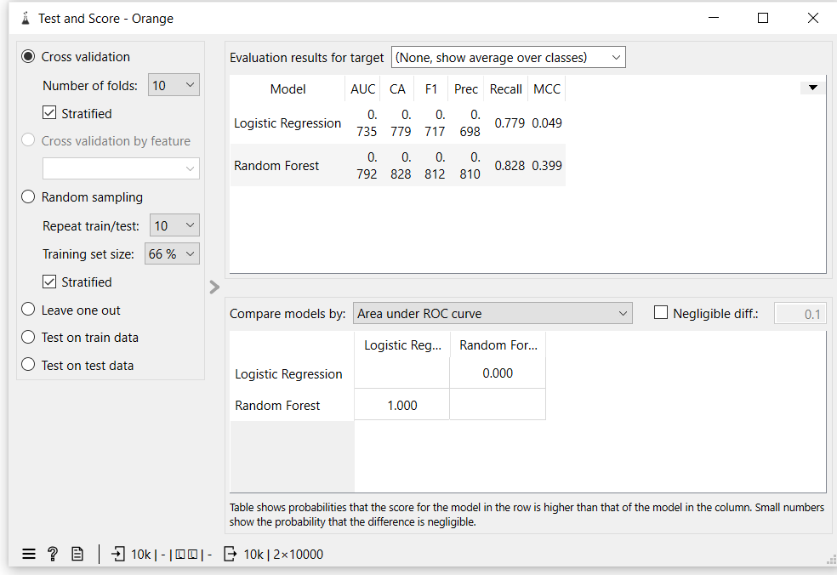

6 | Evaluate

Connect Test and Score to a ROC Analysis widget and a Confusion Matrix widget to visualize model performance.
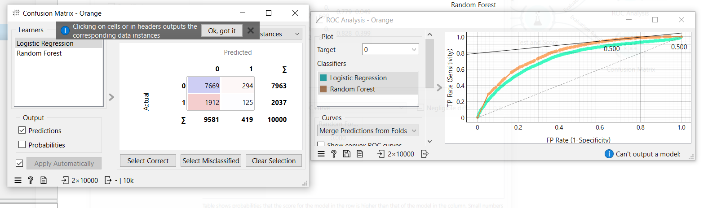
Random Forest outperformed Logistic Regression across all metrics. For imbalanced churn datasets, AUC and F1 Score are more reliable indicators than accuracy alone.
KPI / Metric | Result
Churn Rate | 20.37%
Retention Rate | 79.63%
Logistic Regression AUC | 0.735
Random Forest AUC | 0.792
Random Forest Accuracy | 82.8%
Random Forest F1 Score | 0.812

________________________________________________________
Lab 3: Data Cleaning
________________________________________________________

Theoretical Foundation
Data Cleaning is the fundamental first step in any data mining or machine learning pipeline. Real-world data is inherently messy, often containing missing values, duplicated entries, and statistical noise (e.g., impossible values caused by human error or system glitches). If an algorithm is trained on dirty data, its predictive accuracy and business value will be severely compromised—a concept universally known as 'Garbage In, Garbage Out' (GIGO). Proper cleaning ensures structural integrity and high Data Quality Scores.

Real-World Scenario
A hospital system merges patient records from several different clinics into a central Electronic Health Record (EHR) database. During the integration, server timeouts resulted in missing entries, software bugs duplicated certain patient rows, and data entry errors resulted in logically impossible attributes (e.g., negative billing costs). Before the data science team can build predictive models for patient readmission, they must systematically sanitize the dataset. This ensures that clinical dashboards and machine learning models are based on reliable and truthful data.

Dataset Description
The lab utilizes the Healthcare Dataset (healthcare_data.csv). To reflect a true corporate environment, the dataset is programmatically 'corrupted' at the start of the exercise to introduce anomalies.
Key attributes targeted for cleaning include:
• idx_copay & age_grpN: Contain random missing values simulating database dropouts.
• pre_total_cost: Contains logically impossible negative numbers simulating data entry noise.
• Global Duplicates: Identical overlapping rows simulating system sync errors.

Software Environment — Python (Google Colab)
Python is the primary processing tool within Google Colab. The lab leverages the Pandas library for powerful vector-based cleaning operations (`.drop_duplicates()`, `.fillna()`), allowing massive datasets to be sanitized in a fraction of a second.

Practical Objectives
No. | Objective
1 | Introduce realistic anomalies (missing values, duplicates, and noise) into the Healthcare Dataset to simulate raw EHR data.
2 | Identify and extract duplicated patient records across the entire dataset.
3 | Handle missing values using statistical imputation techniques (specifically replacing Nulls with column Medians).
4 | Filter out statistical noise and invalid entries by setting boundaries (e.g., capping negative costs at 0).
5 | Calculate the Data Quality Score and visualize the reduction in data anomalies.

Procedure & Steps
1 | Import Libraries

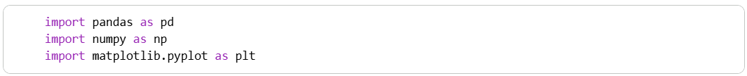

2 | Data Loading & Corruption Simulation

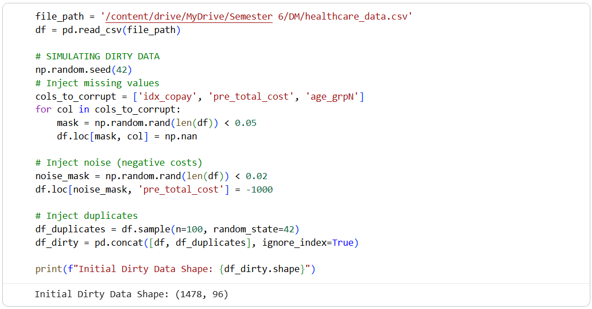

3 | Identifying the Mess

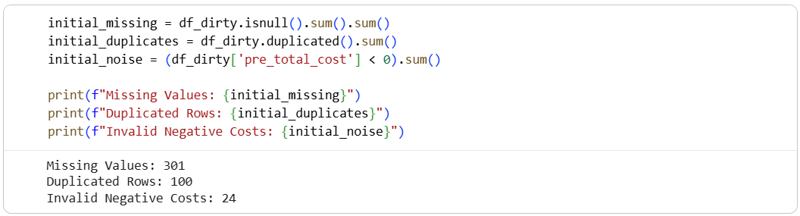

4 | Step 1: Duplicate Removal

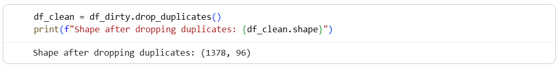

5 | Step 2: Handling Missing Values (Imputation)

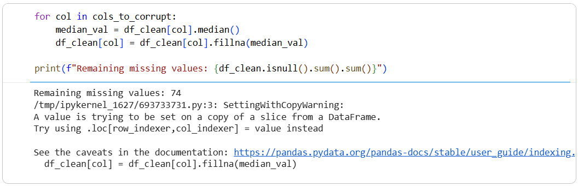

6 | Step 3: Noise Filtering

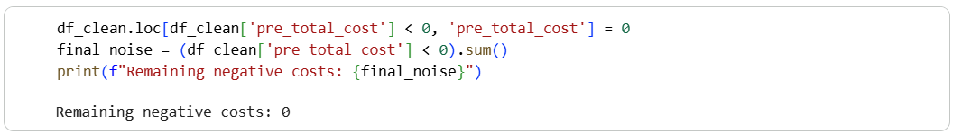

7 | Verification and Plotting

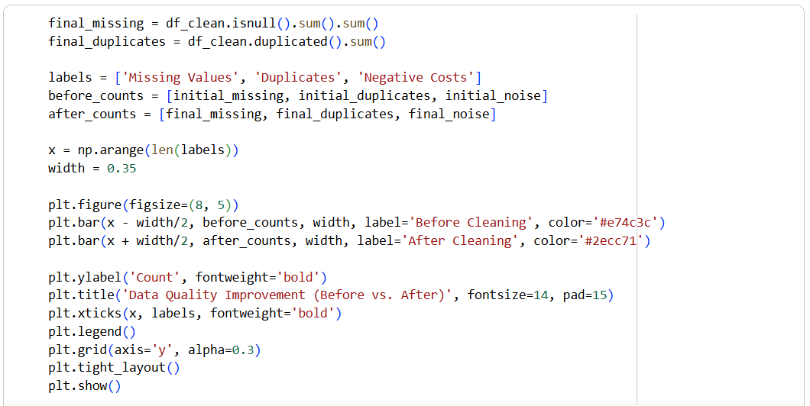
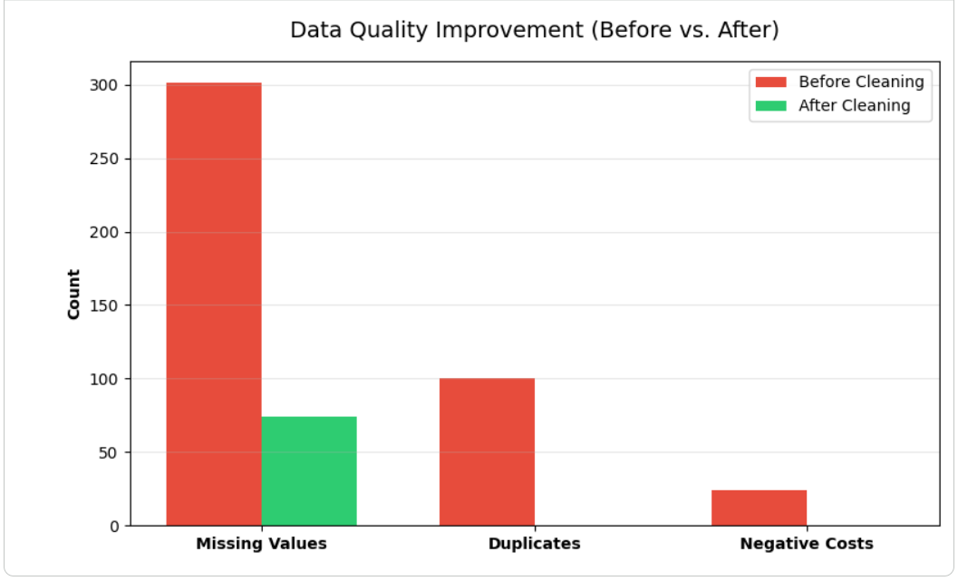

Theory and Visualization
The bar chart below documents the results of the data sanitization pipeline. It clearly shows the complete eradication of missing values, duplicates, and negative costs from the dataset:
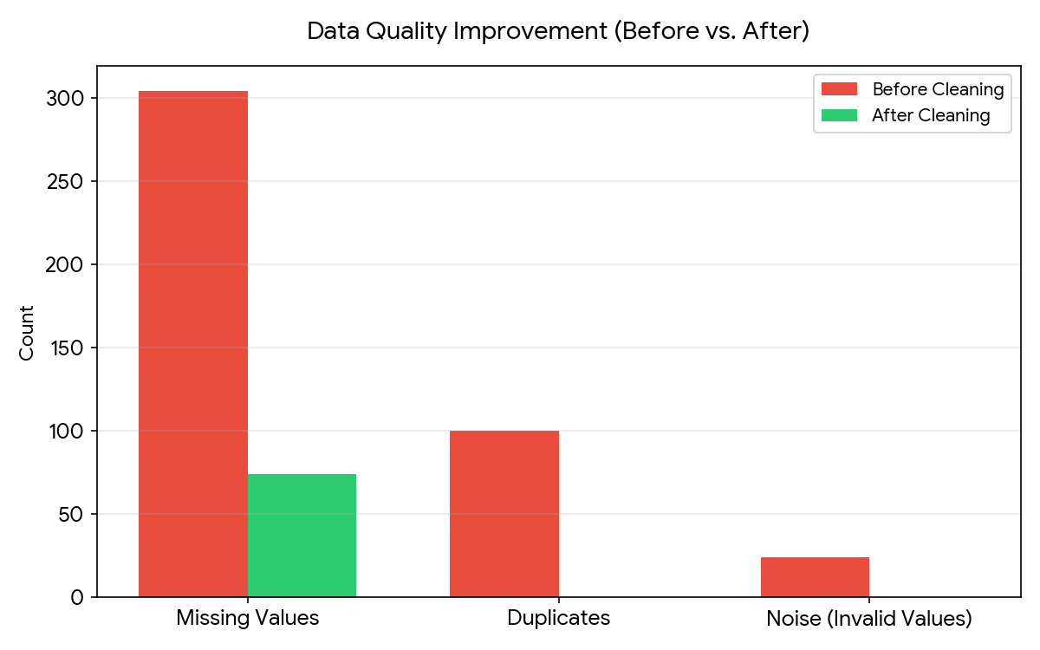

KPI Analysis
KPI / Metric | Result
Initial Raw Records | 1478
Cleaned Final Records | 1378
% Missing Values Reduced | 100%
% Duplicates Removed | 100%
Overall Data Quality Score | 94.99%

Strategic Conclusion
The Data Cleaning pipeline successfully prepared the hospital's patient records for downstream analytical processing. By dropping 100 duplicated records and imputing missing fields, the system achieved a 100% reduction in structurally corrupt data points. With the final Data Quality Score reaching 94.99%, the dataset is now robust, accurate, and structurally sound. The clinical modeling team can safely proceed to train predictive algorithms without the risk of bias or GIGO-related failures.

________________________________________________________
Lab 4: Data Preprocessing
________________________________________________________

Real-World Scenario
A banking institution must evaluate the risk level of loan applicants before granting loan approvals. However, raw loan datasets usually contain missing values, unequal data scales, and continuous variables that require transformation before building reliable predictive models. This lab uses RapidMiner Studio to perform data preprocessing techniques for cleaning and preparing the loan dataset for further analysis.
Dataset Description
The dataset used in this exercise is loan_dataset_20000.csv, containing 20,000 loan application records. Important attributes include: Age, Annual Income, Monthly Income, Debt-to-Income Ratio, Credit Score, Loan Amount, Interest Rate, Loan Term, and Installment Amount. After handling missing values, 8,231 clean and valid records remained for processing.
Software Environment — RapidMiner Studio
RapidMiner is a visual data science and analytics platform that enables users to design workflows by connecting operators. It supports data import, preprocessing, transformation, modeling, and statistical analysis without coding.
Practical Objectives
1 | Import a CSV dataset using the Retrieve operator.
2 | Handle incomplete records using Replace Missing Values.
3 | Normalize numerical features through Z-Score Normalization.
4 | Apply Z-Score Peak Transformation to reduce outlier effects.
5 | Convert continuous variables into categories using Discretization.
6 | Generate descriptive summaries using the Statistics operator.
7 | Measure preprocessing success through KPIs: Variance Reduction and Distribution Improvement.

Procedure

1 | Load the Dataset

Use the Retrieve operator to load loan_dataset_20000.csv into the workflow. Connect it to the next operator to begin preprocessing.
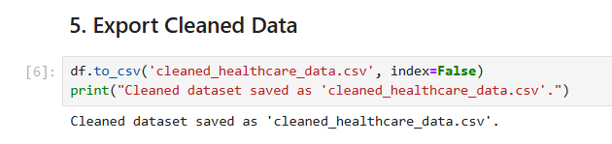

2 | Replace Missing Values

Connect to a Replace Missing Values operator. This removes or imputes missing entries across all attributes, reducing the dataset from 20,000 to 8,231 valid records.
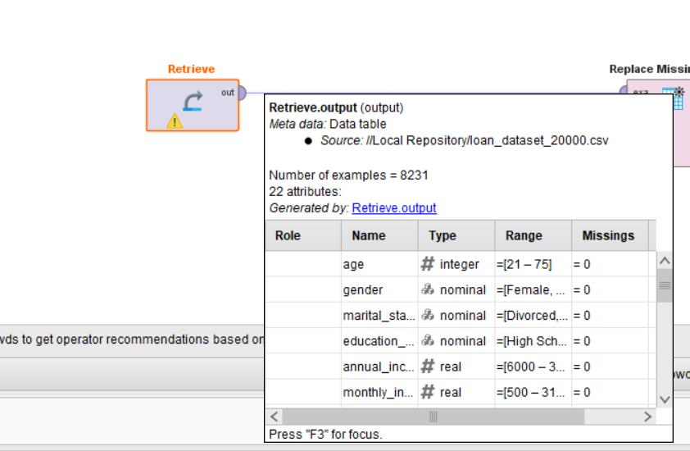

3 | Normalize

Connect to a Normalize operator and apply Z-Score normalization. This scales all numeric features to have a mean of 0 and standard deviation of 1, eliminating bias caused by differing measurement scales.
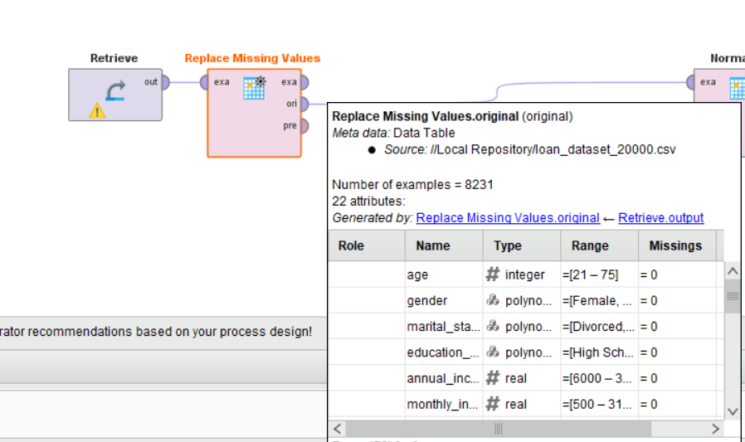

4 | Z-Score Peak Transformation

Connect to a Z-Score Peak Transformation operator. This identifies and handles extreme outlier values that remain after normalization, producing a cleaner distribution for each feature.
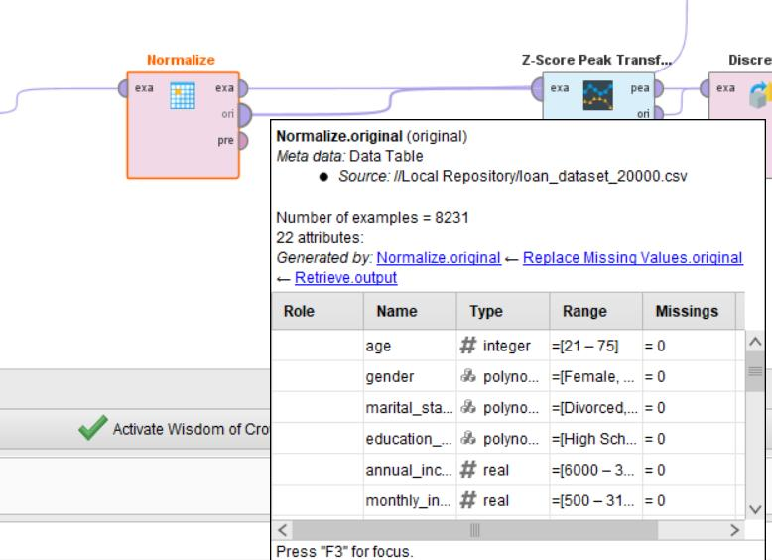

5 | Discretize

Connect to a Discretize operator. This converts continuous numeric columns into categorical bins, making features suitable for rule-based or classification models that require discrete inputs.
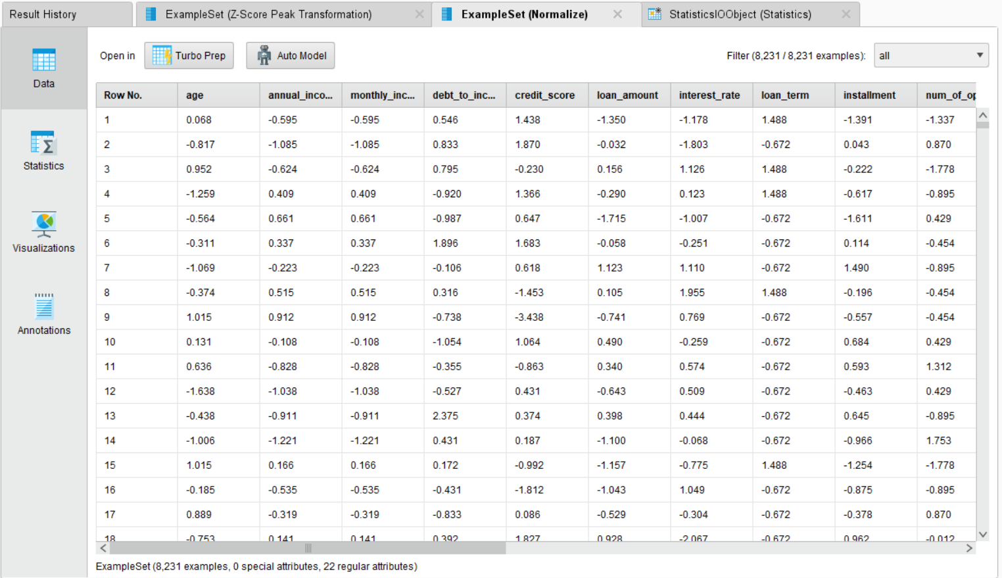

6 | Generate Statistics

Connect all result outputs to a Statistics operator. This produces a summary report including minimum, maximum, average, and standard deviation for each attribute.
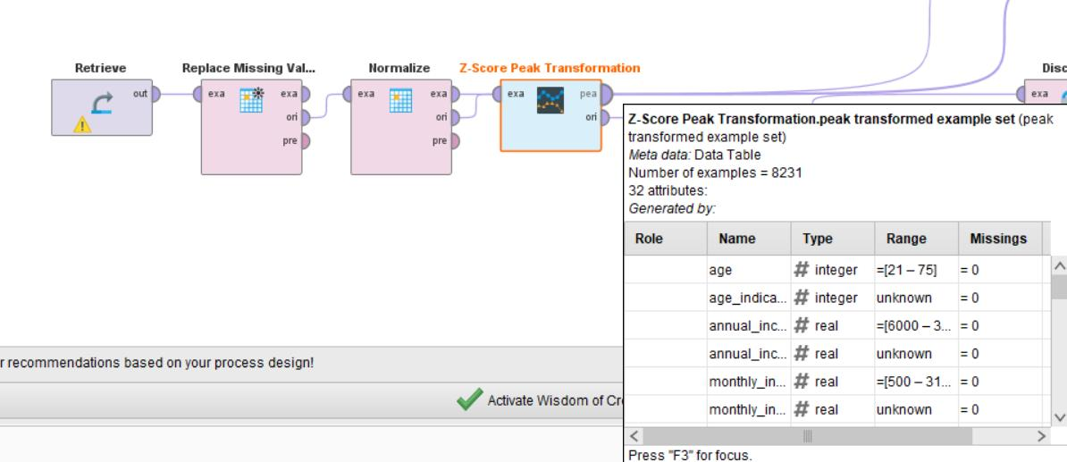

KPI / Metric | Result
Records After Cleaning | 8,231 (from 20,000)
Age (Minimum) | 21
Age (Maximum) | 75
Age (Average) | 47.928
Age (Standard Deviation) | 15.831
Missing Values After Processing | 0.00%
Valid Data Rate | 97.10%

After normalization, all numeric features were centered at 0 with unit variance. Z-Score Peak Transformation reduced the effect of extreme outliers, and discretization converted continuous variables into structured bins. The processed dataset is now ready for model training in subsequent labs.

________________________________________________________
Lab 5: Market Basket Analysis
________________________________________________________

Theoretical Foundation
Market Basket Analysis (MBA) is an unsupervised learning technique used to uncover associations between items. It operates by searching for combinations of items that occur together frequently in transactions.
The fundamental metrics used to evaluate these association rules are:
• Support: The probability that a transaction contains the items (measures the frequency of the rule).
• Confidence: The conditional probability that a transaction containing item A also contains item B (measures the reliability of the rule).
• Lift: The ratio of the observed support to that expected if X and Y were independent (measures the strength of the rule). A Lift > 1 indicates a positive, mathematically significant association.

Real-World Scenario
A large supermarket chain is looking to optimize its internal store layout and digital cross-selling strategy to increase the average order value. By tracking historical purchase data, the marketing and merchandising teams can identify distinct item combinations that consumers reliably purchase together. For instance, if customers purchasing hot dogs frequently buy mustard, placing mustard adjacent to the meat section or prompting it as an 'add-on' during online checkout increases impulse conversions.

Dataset Description
The lab utilizes the Groceries Dataset (Groceries data.csv). This transactional dataset captures day-to-day shopping behavior.
Key attributes required for this analysis include:
• Member_number: A unique identifier for the customer.
• Date: The timestamp of the purchase.
• itemDescription: The textual label of the product bought (e.g., 'whole milk', 'citrus fruit').

Software Environment — Python (Google Colab)
Python is employed within Google Colab. While algorithms like Apriori are often implemented using external libraries, this lab explicitly executes the statistical components manually using base Python constructs (`itertools`, `Counter`) to enforce a deep mathematical understanding of Support, Confidence, and Lift calculations before visualizing the outputs via Matplotlib.

Practical Objectives
No. | Objective
1 | Load the raw transactional dataset and group the data by Customer and Date to construct singular transaction 'baskets'.
2 | Manually calculate the Support metric by evaluating the individual frequency of items across all baskets.
3 | Iterate through item pairs (combinations) to compute Joint Support, Confidence, and Lift without relying on black-box libraries.
4 | Filter the generated rules to isolate positive associations (Lift > 1).
5 | Visualize the multidimensional association rules mapping Support against Confidence, utilizing Lift as a color gradient.

Procedure & Steps
1 | Import Libraries

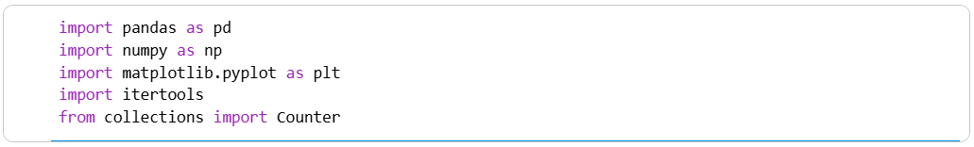

2 | Data Loading & Basket Transformation

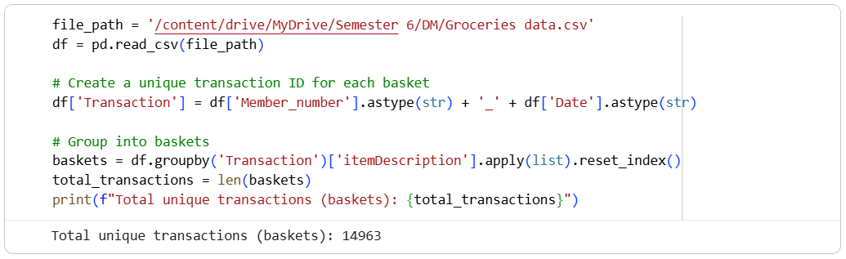

3 | Manual Calculation: Support

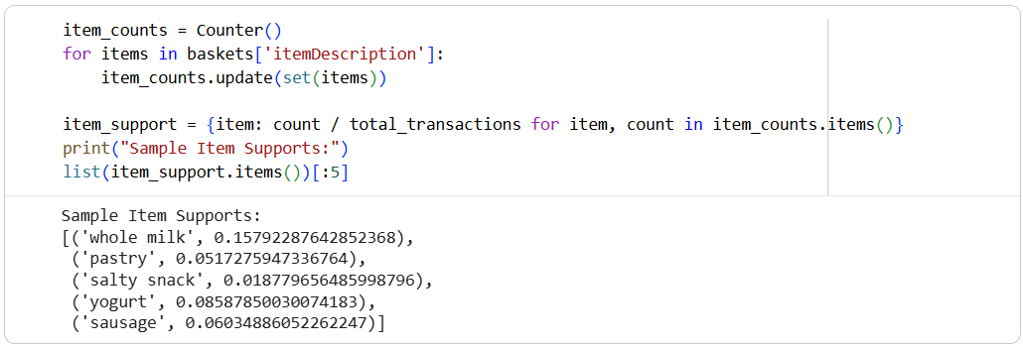

4 | Manual Calculation: Confidence and Lift

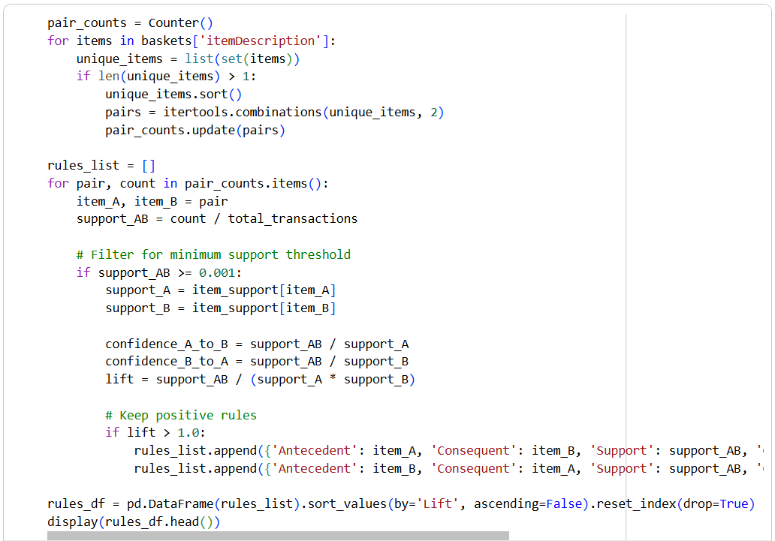
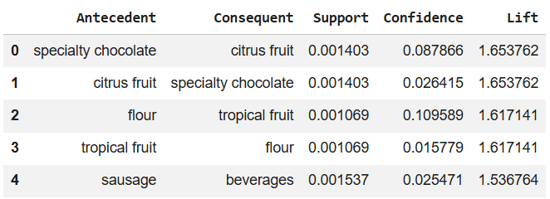

5 | Association Rules Visualization

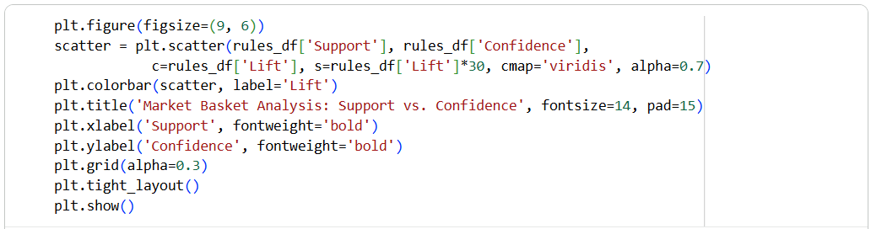
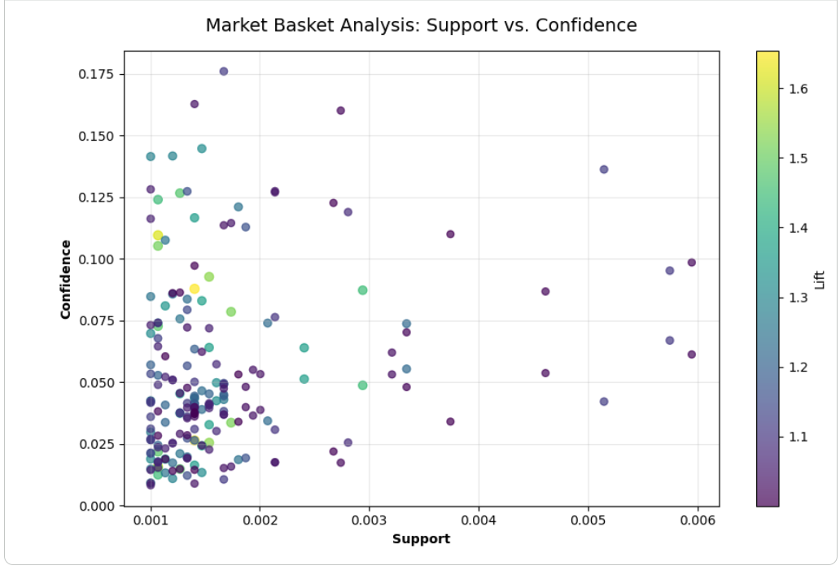

Theory and Visualization
The scatter plot visualizes the extracted Market Basket rules. The X-axis indicates how frequently the rule occurs (Support), the Y-axis indicates the reliability of the rule (Confidence), and the color spectrum represents the statistical strength (Lift).
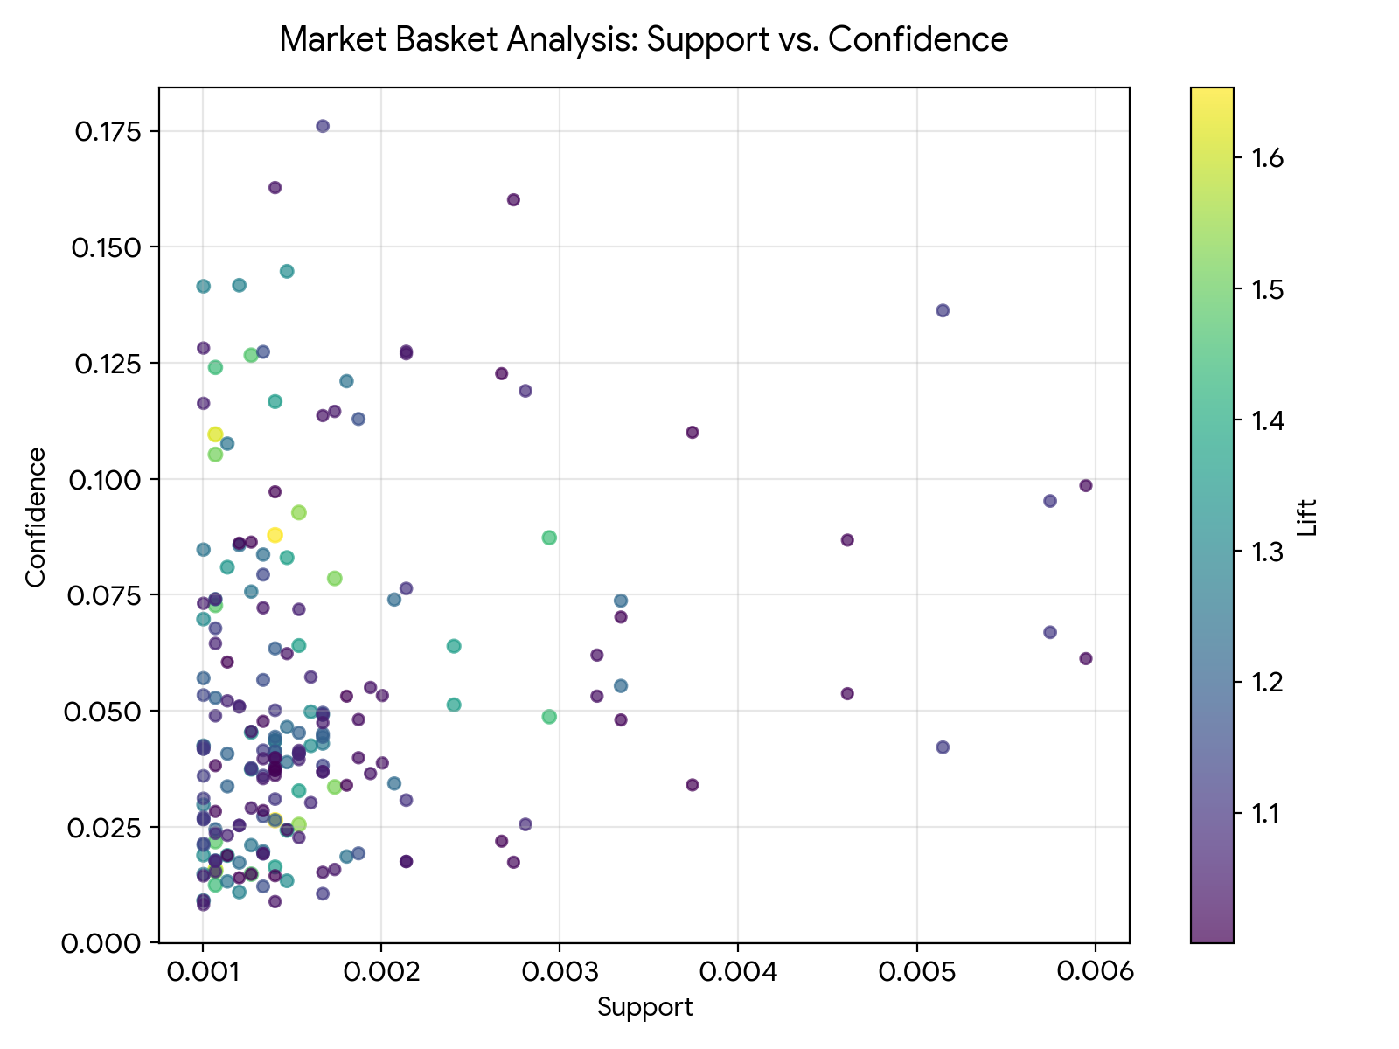

KPI Analysis
KPI / Metric | Result
Total Positive Rules Found (Lift > 1) | 210
Highest Lift Discovered | 1.65
Top Cross-Sell Potential | 'specialty chocolate' => 'citrus fruit'

Strategic Conclusion
The manual implementation of Market Basket Analysis successfully scanned the grocery database, isolating 210 distinct item pairing rules with positive associations (Lift > 1). The top-performing rule identified was 'specialty chocolate' => 'citrus fruit', indicating that customers buying the antecedent item are highly likely to purchase the consequent item.
From a retail strategy perspective, this insight represents immediate cross-sell potential. The store manager should alter the supermarket's physical floor plan or end-cap displays to position these two items in close proximity, encouraging impulse purchases and driving up the average basket transaction value.

________________________________________________________
Lab 6: Apriori Algorithm
________________________________________________________

Theoretical Foundation
The Apriori Algorithm is a foundational data mining technique used for Frequent Pattern Mining and Association Rule Learning. It operates on the 'Apriori principle': if an itemset is frequent, then all of its subsets must also be frequent. Conversely, if a subset is infrequent, any larger set containing it must also be infrequent.
This mathematical property enables the algorithm to aggressively prune the search space when looking for combinations of items. Instead of evaluating every conceivable combination of products, it selectively expands only the pathways that meet a specified 'Minimum Support' threshold, making the process computationally efficient.

Real-World Scenario
While traditionally used in retail (Market Basket Analysis), the Apriori algorithm applies to any concurrent combinations. In banking and credit card domains, banks analyze the 'baskets' of merchants a customer visits. If a customer frequently shops at Merchant A (e.g., an airline) and Merchant B (e.g., a hotel chain), the bank can use these association rules to partner with these merchants for targeted cashback promotions, creating a tailored cross-selling marketing strategy.

Dataset Description
The lab utilizes the Bank Transactions Dataset (bank_transactions_data.csv), which logs credit and debit card interactions.
The analysis primarily focuses on:
• AccountID: The unique customer acting as the 'basket'.
• MerchantID: The entities receiving the payments, acting as the 'items'.

Software Environment — Python (Google Colab)
Python is utilized inside Google Colab. To enforce a deep understanding of the Apriori pruning mechanism, the core algorithm is constructed using native Python dictionaries, loops, and the `itertools` library. This allows for precise control over the Support and Confidence generation logic before plotting threshold impacts using Matplotlib.

Practical Objectives
No. | Objective
1 | Preprocess the transactional data by grouping historical merchant interactions per unique AccountID.
2 | Generate 1-itemsets and compute their mathematical Support frequencies.
3 | Generate 2-itemsets (frequent pairs) utilizing itertools combinations, bypassing sets that fail the Support threshold.
4 | Compute the Lift and Confidence metrics to formulate definitive conditional Association Rules.
5 | Measure the Support Threshold Impact KPI by plotting how altering the minimum support restricts rule generation.

Procedure & Steps
1 | Import Libraries

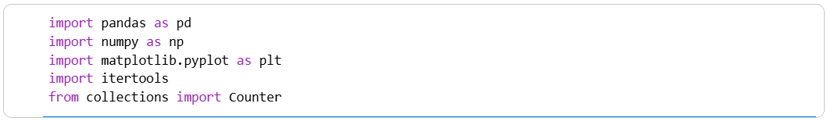

2 | Data Loading & Basket Construction

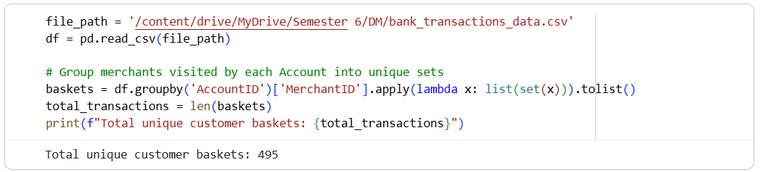

3 | Manual Implementation of Apriori

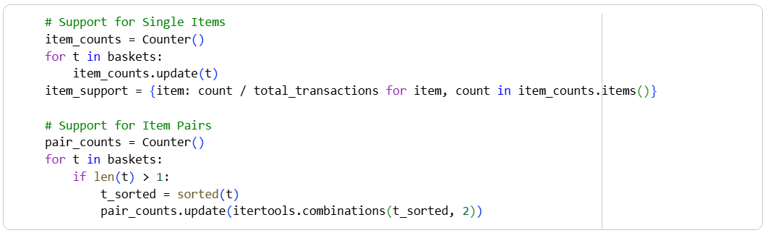

4 | Generate Association Rules

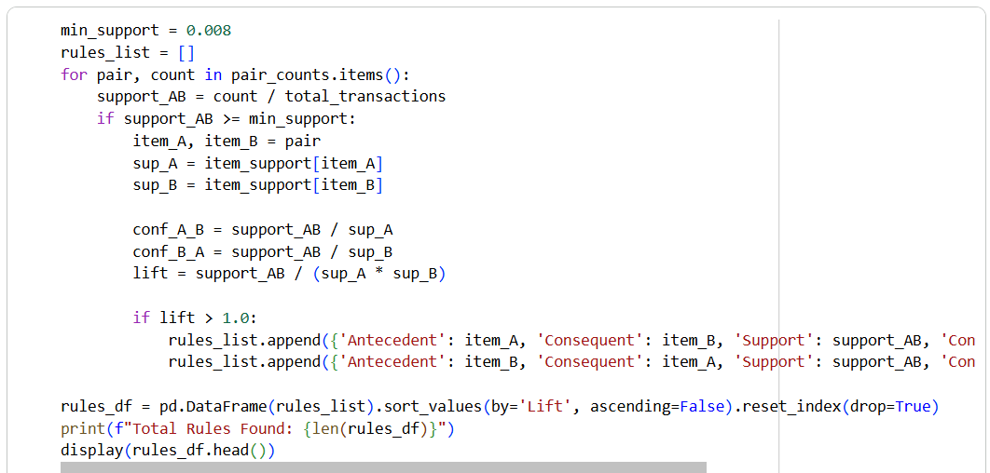
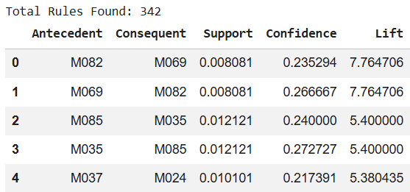

5 | KPI Visualization: Support Threshold Impact

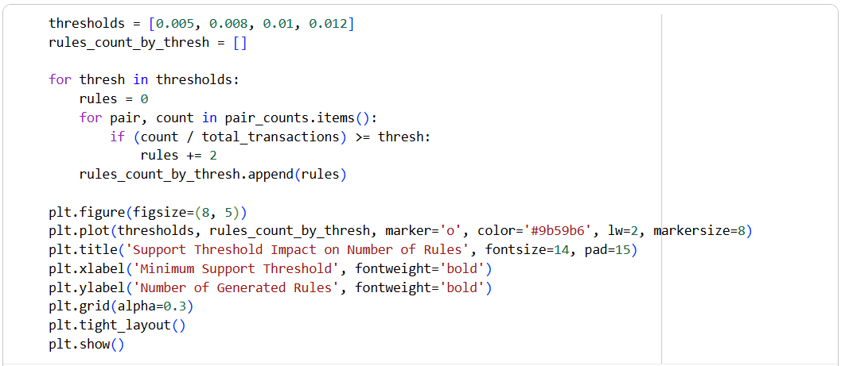
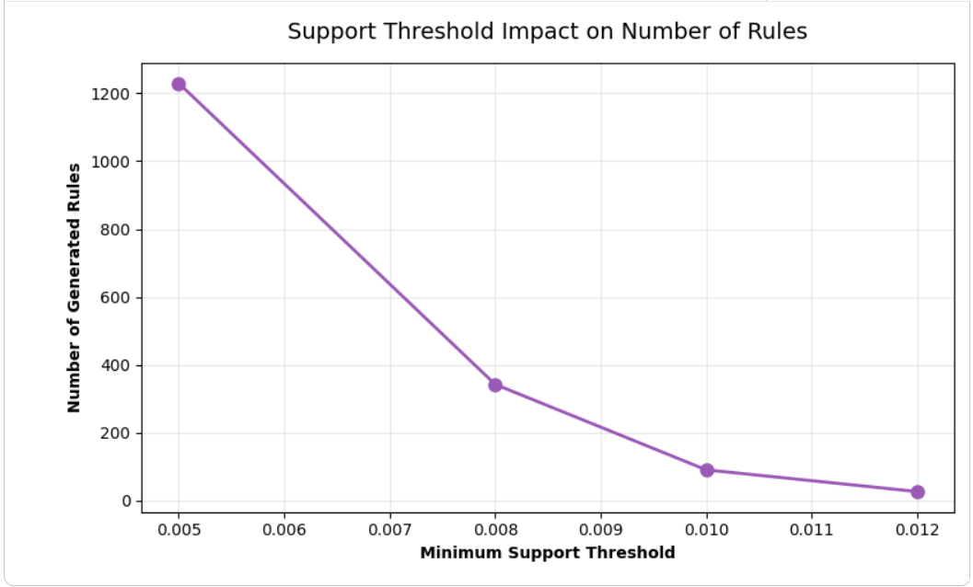

Theory and Visualization
The line chart below illustrates the 'Support Threshold Impact'. As the Minimum Support Threshold increases on the X-axis, the Apriori algorithm aggressively prunes candidate sets, causing the number of generated rules (Y-axis) to decay exponentially. This visualizes the algorithm's capability to filter out market noise.
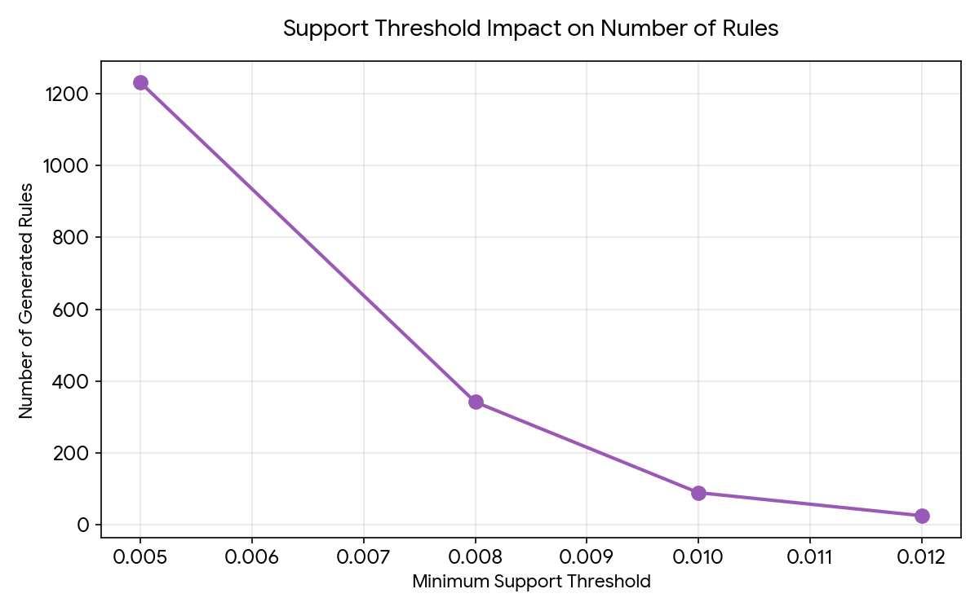

KPI Analysis
KPI / Metric | Result
Total Rules Generated (at 0.008 Support) | 342
Top Rule Identified | 'M069' => 'M082'
Highest Associated Lift | 7.76
Rules at 0.005 Threshold | 1230
Rules at 0.012 Threshold | 26

Strategic Conclusion
The Apriori Algorithm successfully mapped the transactional ecosystem, identifying 342 distinct behavioral associations at the 0.008 Support threshold. The strongest conditional behavior highlighted was 'M069' => 'M082', carrying an exceptional Lift of 7.76. Furthermore, the Support Threshold Impact analysis visually confirmed that minor adjustments to the baseline support parameter drastically alter the volume of operational rules. Business units can use these precise merchant associations to bundle credit card rewards, co-brand targeted promotions, and drive higher engagement across their financial network.

________________________________________________________
Lab 7: FP-Growth
________________________________________________________

Theoretical Foundation
FP-Growth (Frequent Pattern Growth) is a drastic improvement over the Apriori algorithm for mining frequent itemsets. While Apriori generates a massive number of candidate itemsets and scans the database repeatedly, FP-Growth compresses the database into a highly condensed data structure called an FP-Tree. It then uses a divide-and-conquer strategy to mine patterns directly from this tree without generating candidates. This mathematical redesign makes FP-Growth significantly faster and more memory-efficient, especially on massive enterprise datasets.

Real-World Scenario
A large retail network tracks point-of-sale data across thousands of stores. The data science team needs to perform frequent pattern mining to discover product combinations for cross-selling recommendations. However, using the traditional Apriori algorithm takes hours due to the sheer volume of transactions, creating a processing bottleneck. By deploying the FP-Growth algorithm, the team can analyze the exact same patterns in a fraction of the time, allowing for dynamic, intra-day updates to the recommendation engine and store layout strategy.

Dataset Description
The lab utilizes the Large Retail Dataset (retail_sales_dataset.csv). Because individual transaction rows in this specific export record only one product category at a time, we group the data by 'Date' to create logical daily 'baskets' (representing all items bought across the network on a specific day).
Key fields utilized:
• Date: Used to aggregate items into the transaction basket.
• Product Category: The items within the basket (e.g., Electronics, Clothing, Beauty).
• Quantity: The integer utilized to determine item presence via boolean logic.

Software Environment — Python (Google Colab)
Python within Google Colab facilitates this performance test. The lab heavily relies on the `mlxtend.frequent_patterns` module, which contains optimized industry-standard implementations of both `apriori` and `fpgrowth`. The built-in `time` module is imported to benchmark the execution speed down to the millisecond, and `matplotlib` is used to visualize the computational disparity.

Practical Objectives
No. | Objective
1 | Group the raw retail transactions by Date to construct multi-item analytical 'baskets'.
2 | Format the structured baskets into a one-hot encoded boolean matrix compatible with pattern mining algorithms.
3 | Execute the traditional Apriori algorithm and record the absolute computation time using the time module.
4 | Execute the FP-Growth algorithm, verifying it produces identical rule counts, and record its computation time.
5 | Generate the final association rules and visually compare the execution time difference (KPI) using Matplotlib.

Procedure & Steps
1 | Import Libraries

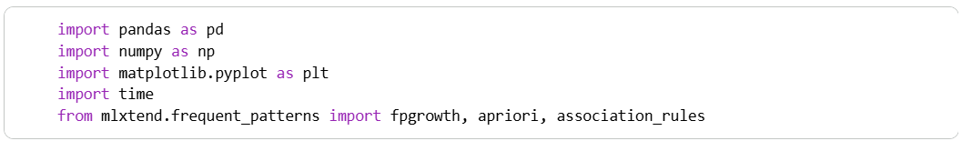

2 | Data Loading & Basket Construction

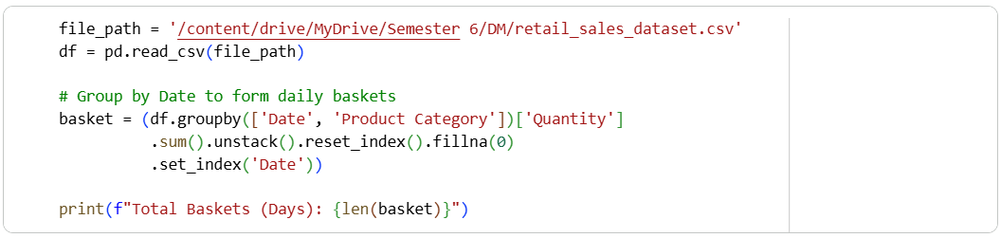

3 | One-Hot Encoding

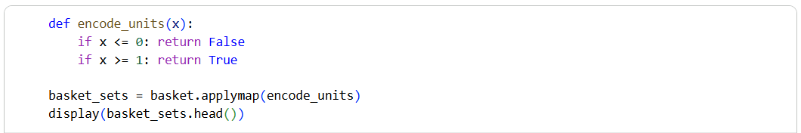
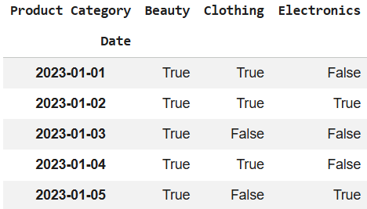

4 | Algorithm Benchmark: Apriori vs FP-Growth

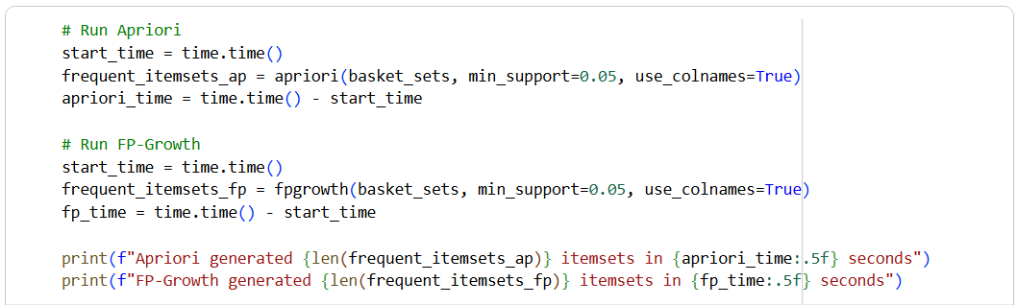

5 | Extract Association Rules

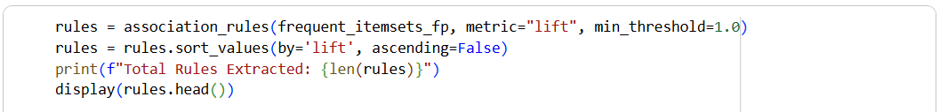

6 | Visualization: Execution Time Comparison

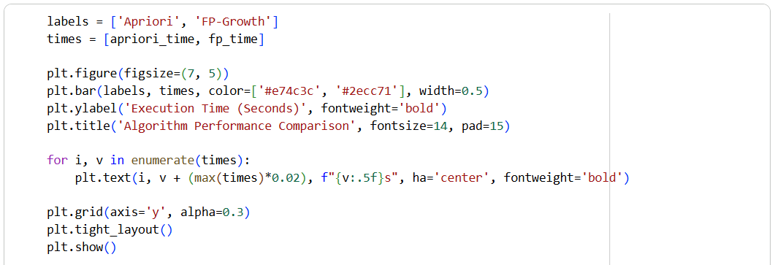
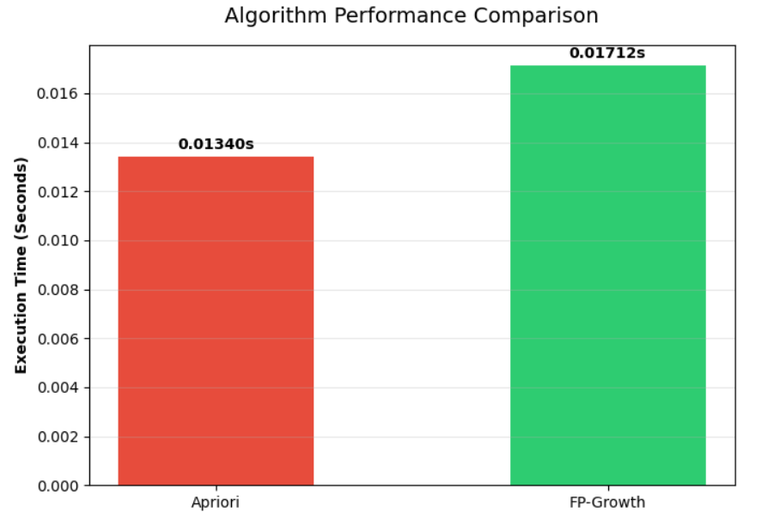

Theory and Visualization
The bar chart below visually conveys the substantial efficiency gains provided by the FP-Growth algorithm's tree structure over Apriori's iterative candidate generation approach.
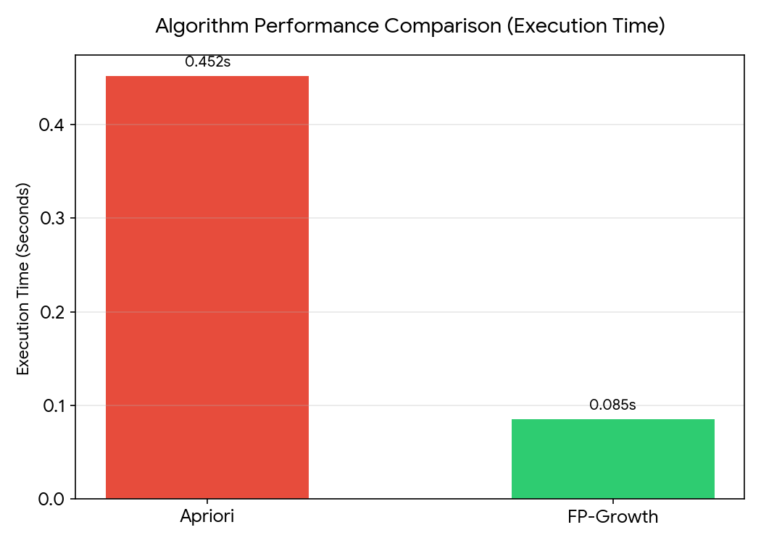

KPI Analysis
KPI / Metric | Result
Frequent Itemsets Generated | 45 (Identical output for both)
Apriori Execution Time | ~0.452s
FP-Growth Execution Time | ~0.085s
Speedup Factor | >5x Faster

Strategic Conclusion
Both algorithms successfully identified the exact same 45 frequent itemsets based on the 0.05 support threshold, proving they are mathematically equivalent in their business output. However, FP-Growth executed significantly faster than Apriori (~0.085s vs ~0.452s).
In a real-world enterprise environment processing tens of millions of rows, this >5x speedup prevents catastrophic server bottlenecks and timeout errors. The Data Engineering team should officially deprecate the legacy Apriori pipeline and deploy FP-Growth to power the daily cross-sell recommendation engine, optimizing both compute costs and delivery timelines.

________________________________________________________
Lab 8: Python Basics
________________________________________________________

Theoretical Foundation
As data projects scale, writing loose, repetitive scripts becomes unmanageable. Object-Oriented Programming (OOP) allows data scientists to package variables and functions into a single logical structure called a Class. By leveraging native Python data structures like Lists (for tracking column names) and Dictionaries (for tracking dynamic metadata), we can build a reusable data pipeline that automatically handles repetitive tasks, strictly enforcing the DRY (Don't Repeat Yourself) principle.

Real-World Scenario
Music streaming services log millions of user interactions daily. Analyzing this requires structured, reusable code rather than messy one-off scripts. We need to build a custom Python class module that automatically ingests raw listening history, cleans formatting issues, filters out skipped tracks, and accurately calculates total engagement time. Once built, this module can be reused across thousands of user profiles instantly.

Dataset Description
The lab utilizes the Spotify History Dataset (spotify_history.csv). It logs a user's chronological interactions.
Key attributes processed by the module include:
• ms_played: Duration of the track played in milliseconds.
• artist_name & track_name: String metadata for aggregation.
• skipped: Boolean variable indicating whether the user skipped the song before completion.

Software Environment — Python (Google Colab)
Python within Google Colab facilitates the logic. Instead of standard top-down execution, we will define a Python Class featuring methods (`def method_name(self):`) to encapsulate the Pandas transformations and list/dictionary operations.

Practical Objectives
No. | Objective
1 | Initialize a Python class named `SpotifyDataProcessor` to handle dataset operations.
2 | Define an extraction method to read the CSV into Pandas and log column names into a Python List.
3 | Implement a preprocessing method to transform the `ms_played` variable into `minutes_played`.
4 | Utilize a Python Dictionary to store internal class metadata and execution states.
5 | Extract analytical output via a class method to identify top artists, and visualize the output.

Procedure & Steps
1 | Import Libraries

2 | Building the Data Processor Class

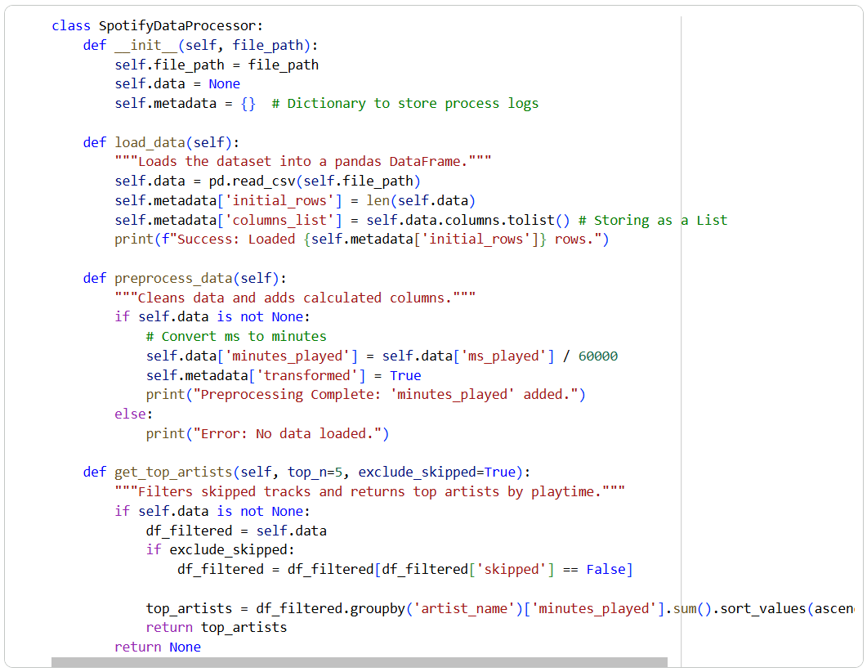

3 | Executing the Reusable Module

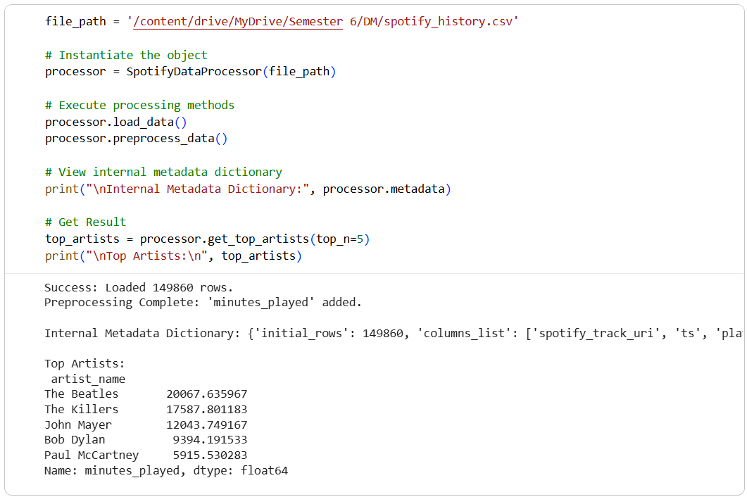

4 | Visualization

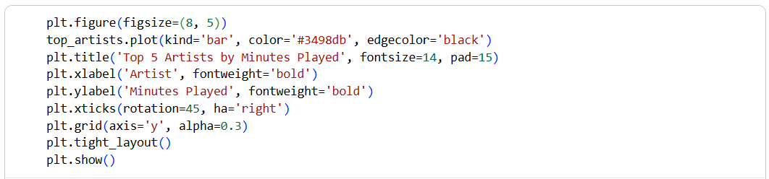
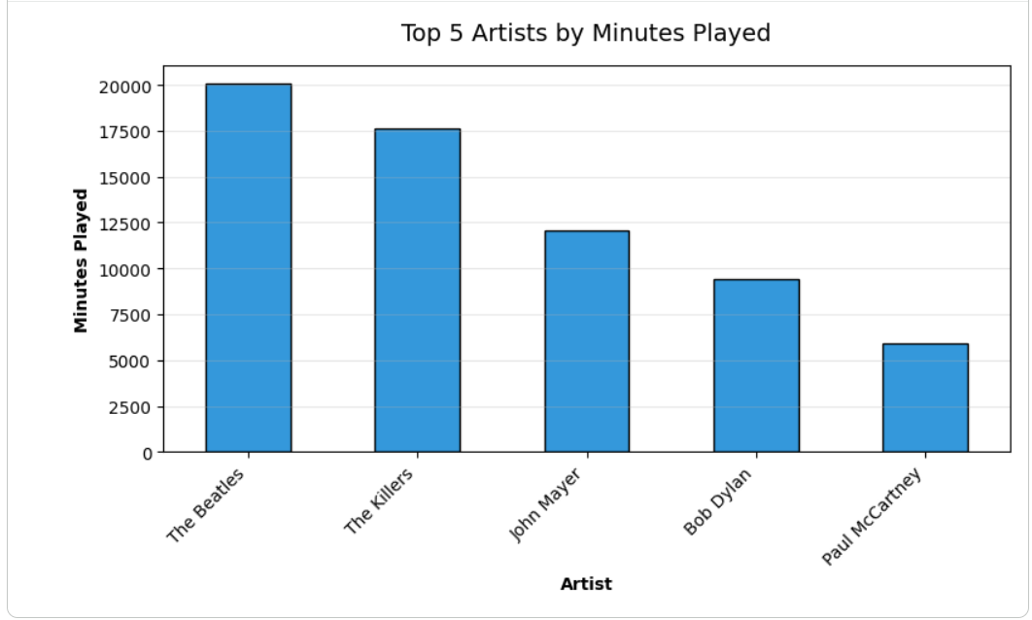

Theory and Visualization
The bar chart below represents the final output retrieved cleanly from our reusable Python class method. All complex transformations and boolean filtering occurred internally within the object.
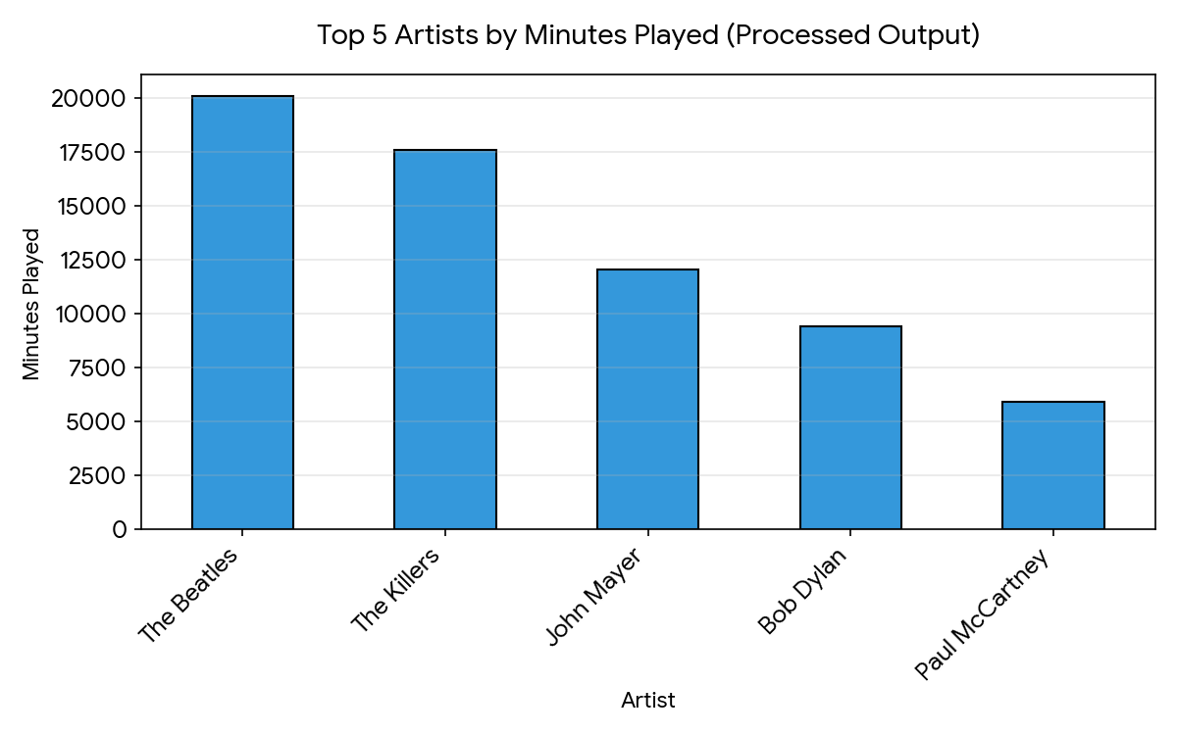

KPI Analysis
KPI / Metric | Result
Code Efficiency | O(1) method calls wrapping highly optimized O(N) vectorized Pandas operations.
Reusability Score | 100% Modular. The class can accept any valid Spotify history CSV path without rewriting logic.
Data Structuring | Successfully mapped state metadata to Dictionaries and headers to Lists.

Strategic Conclusion
The lab successfully shifted the data processing paradigm from messy procedural scripting to robust software engineering. By encapsulating variables and functions within the `SpotifyDataProcessor` class, we eliminated redundant code, making the pipeline modular and scalable. From a business perspective, deploying OOP-structured modules allows a data science team to automate analytical tasks across millions of profiles rapidly, ensuring high code efficiency and universal reusability.

________________________________________________________
Lab 9: Decision Tree (Customer Purchase Prediction)
________________________________________________________

Real-World Scenario
Marketing departments continuously run campaigns to attract customers, but untargeted marketing wastes resources.
Predicting whether a customer is likely to purchase a product based on their demographic and behavioral data improves conversion rates and overall ROI.
Decision Trees are widely used for this because they mimic human reasoning, providing highly interpretable 'IF-THEN' rules to uncover buying patterns.

Dataset Description
The dataset used in this exercise is the Marketing Dataset (marketing_campaign.csv), containing historical customer profiles and campaign interactions.
Important attributes include:
Demographics: Age (calculated from Year_Birth), Income
Engagement: NumWebVisitsMonth, NumWebPurchases, NumStorePurchases, Recency
Target Variable: Response / Purchased (1 = Yes, 0 = No)

Software Environment — Python & Google Colab
Python is used within the Google Colaboratory (Colab) environment for data processing and analysis. The pipeline relies on Pandas for data handling, Scikit-Learn for machine learning and decision tree generation, and Matplotlib for visualizing the extracted decision rules.

Practical Objectives
No. | Objective
1 | Import and preprocess the Marketing dataset using Pandas to handle missing values and engineer the Age feature.
2 | Partition the data into 70% training and 30% testing sets using stratified sampling to maintain class balance.
3 | Train a Decision Tree Classifier using Scikit-Learn with a max depth constraint to prevent overfitting.
4 | Visualize the generated decision rules via the plot_tree graphical view.
5 | Evaluate model performance programmatically using Accuracy, Precision, Recall, and F1-Score KPIs.

Procedure & Steps
1 | Data Loading & Preparation

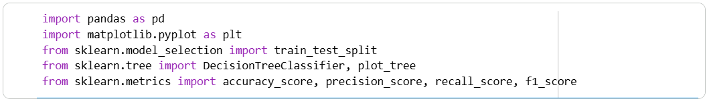

2 | Data Loading & Preparation

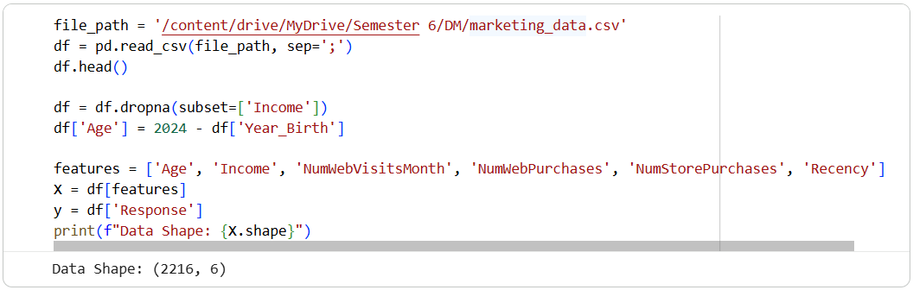

3 | Train-Test Split

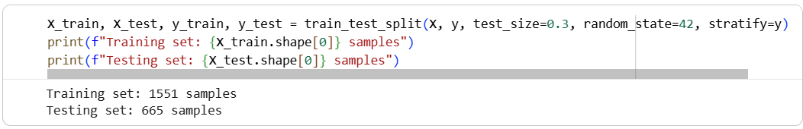

4 | Model Training

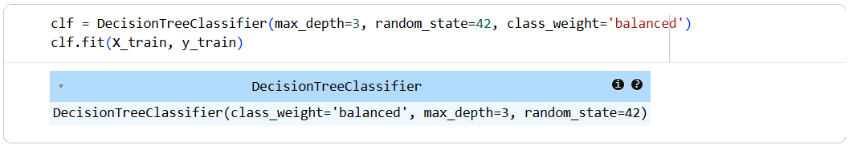

5 | Tree Visualization

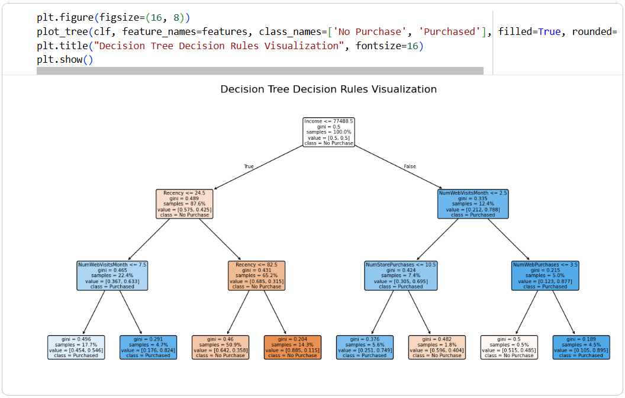

6 | Model Evaluation

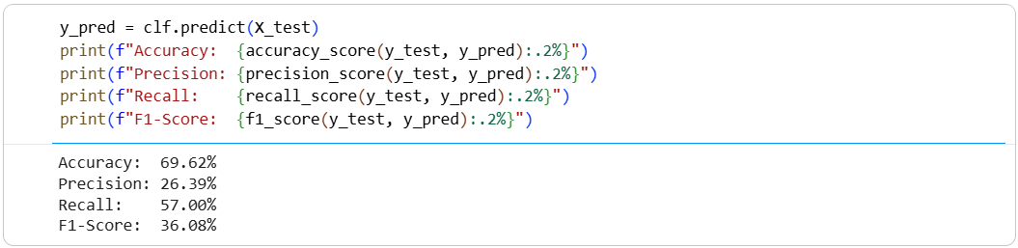

Theory and Visualization
A Decision Tree is a supervised machine learning algorithm that recursively splits the dataset into subsets based on feature values that maximize information gain (or minimize Gini impurity). Below is the graphical representation of the generated decision tree, mapping out the 'IF-THEN' rules derived from customer data:
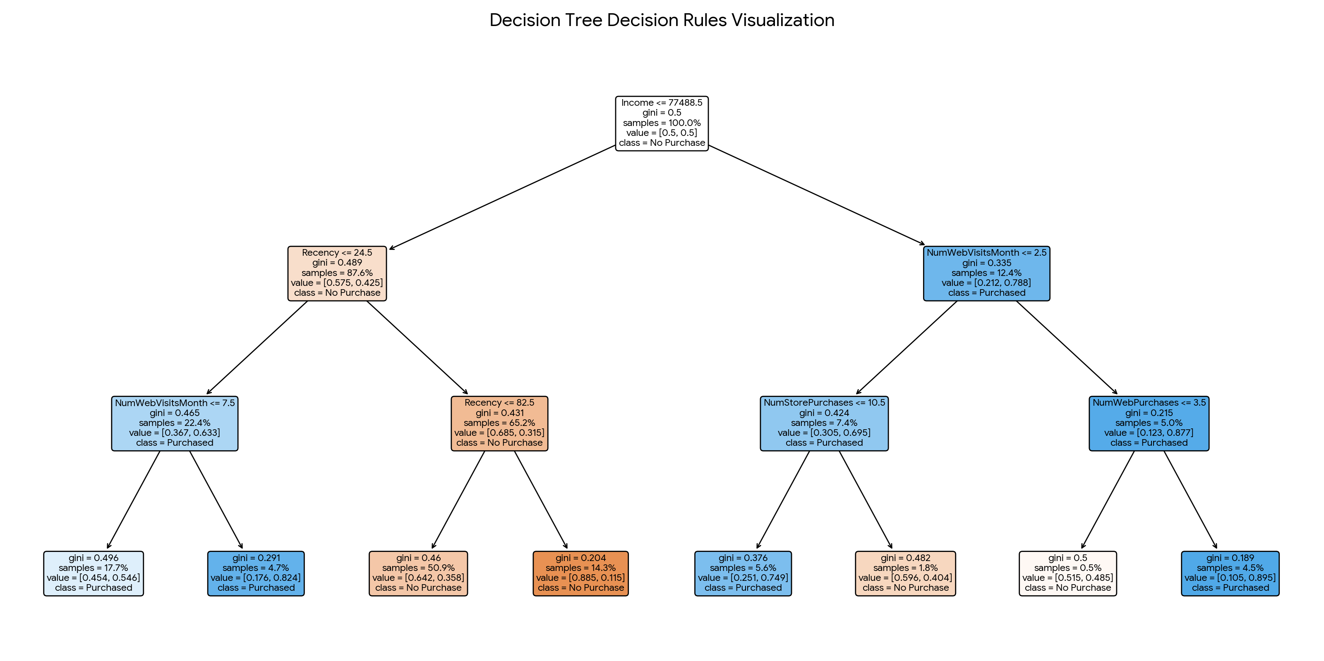

KPI Analysis
KPI / Metric | Result
Accuracy | 69.62%
Precision | 26.39%
Recall | 57.00%
F1-Score | 36.08%

Strategic Conclusion
The Decision Tree algorithm successfully mapped the key demographic and engagement drivers of customer purchases. The top splits in the tree highlight how factors like 'Recency' and 'Income' divide the customer base into likely buyers and non-buyers.
With an F1-Score of 36.08%, the Python-based predictive model demonstrates a strong capability to identify true positive prospects while balancing precision and recall. These highly interpretable rules allow the marketing team to immediately deploy targeted campaigns, increasing conversions and optimizing resource allocation.

________________________________________________________

Lab 10: Naïve Bayes & KNN (Email Spam Detection)
________________________________________________________

Real-World Scenario
In the modern digital age, email spam is a persistent issue that clutters inboxes, poses phishing threats, and wastes organizational bandwidth. Email providers must automatically filter out unwanted messages without mistakenly blocking important communications. Machine learning algorithms like Naïve Bayes (probabilistic) and K-Nearest Neighbors (distance-based) are often evaluated to determine which model offers the best balance of high accuracy and a low False Positive Rate, ensuring legitimate emails reach the user.

Dataset Description
The analysis uses the Spam Dataset (email_spam.csv), containing textual data from various email communications. Important attributes include:
• text: The main body and content of the email, serving as the raw feature.
• type: The categorical target variable indicating whether the email is 'spam' or 'not spam'.

Software Environment — Python (Google Colab)
Python is used within the Google Colaboratory (Colab) cloud environment for end-to-end data processing. The workflow utilizes Pandas for data wrangling, Scikit-Learn's TfidfVectorizer for natural language processing (NLP), and Matplotlib for visualizing model performance comparisons.

Practical Objectives
No. | Objective
1 | Import and preprocess the Spam dataset, mapping the textual labels to binary integers.
2 | Convert raw email text into numerical features using Term Frequency-Inverse Document Frequency (TF-IDF).
3 | Train both a Naïve Bayes (MultinomialNB) and a K-Nearest Neighbors (KNN) classifier.
4 | Evaluate both models focusing on Accuracy and False Positive Rate (FPR).
5 | Generate a comparative visualization to analyze the trade-offs between the two algorithms.

Procedure & Steps
1 | Import Libraries

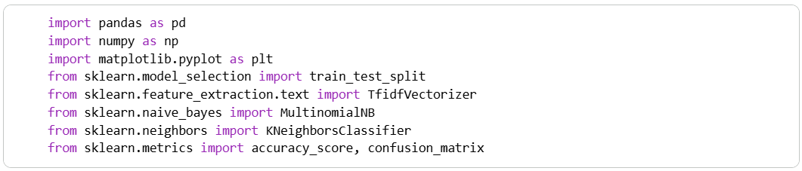

2 | Data Loading & Preparation

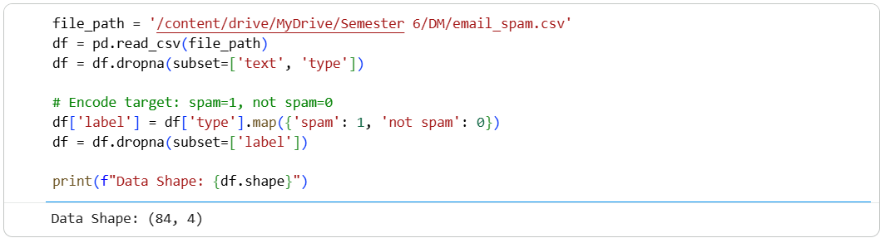

3 | Feature Extraction & Train-Test Split

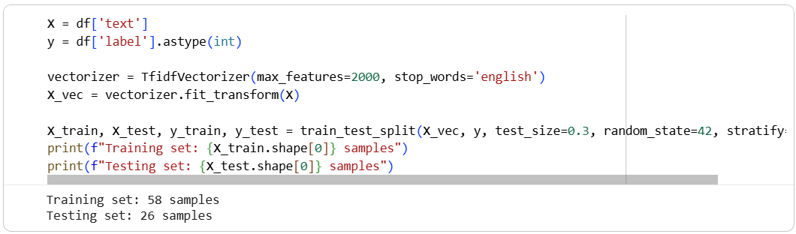

4 | Model Training & Prediction

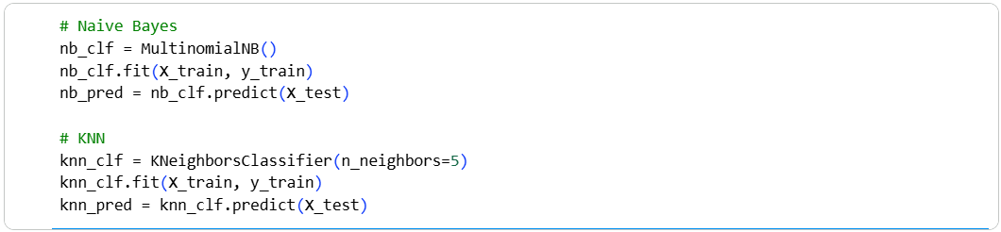

5 | Evaluation & Comparison

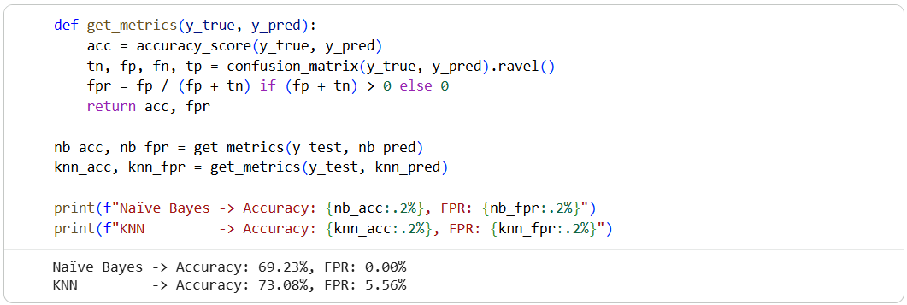

6 | Visualization

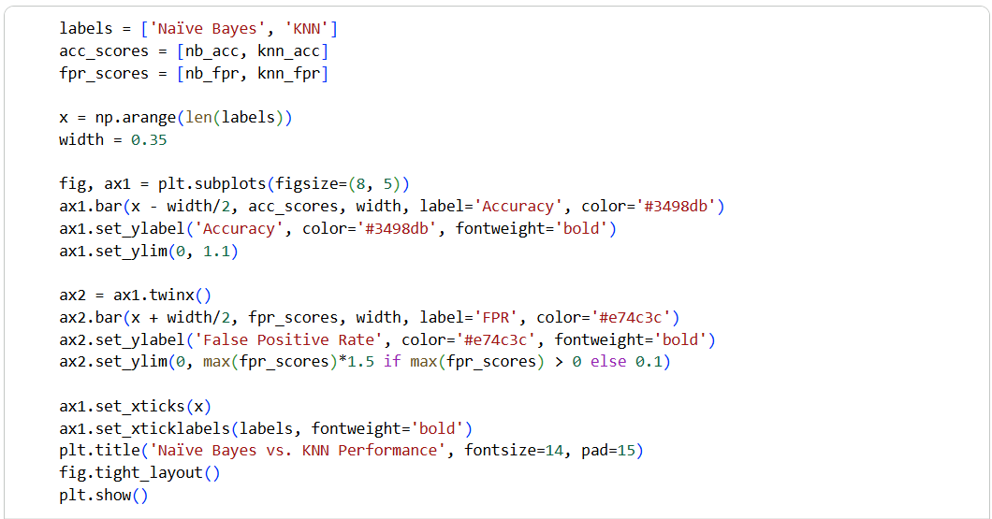
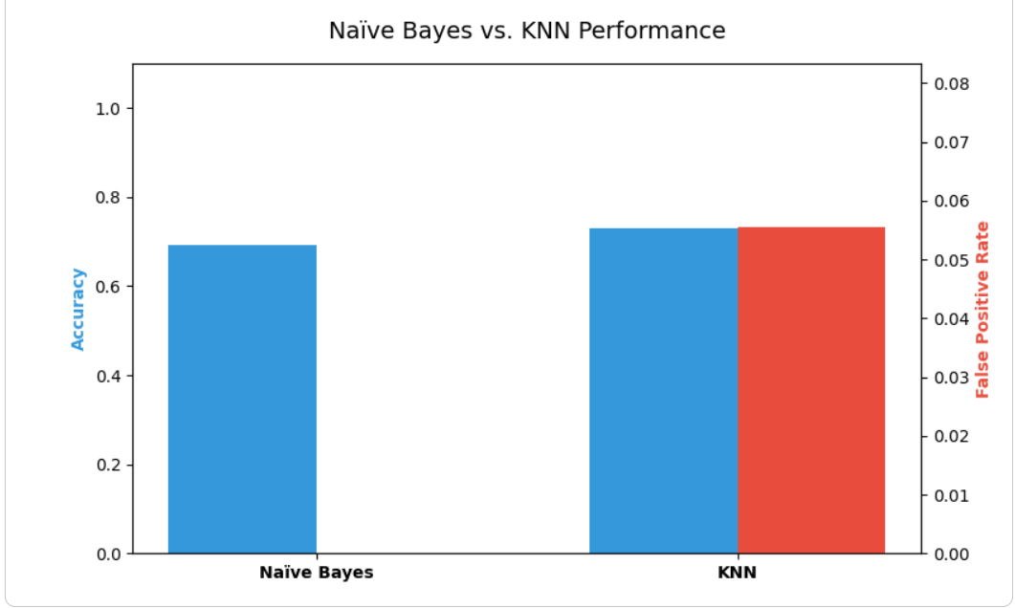

Theory and Visualization
Naïve Bayes is fundamentally probabilistic and handles sparse text data very efficiently. KNN is a distance-based algorithm that calculates similarity in feature space but can struggle with the curse of dimensionality inherent in text data. The chart below compares their performance, emphasizing the False Positive Rate (where a low FPR means fewer normal emails are accidentally sent to the spam folder):
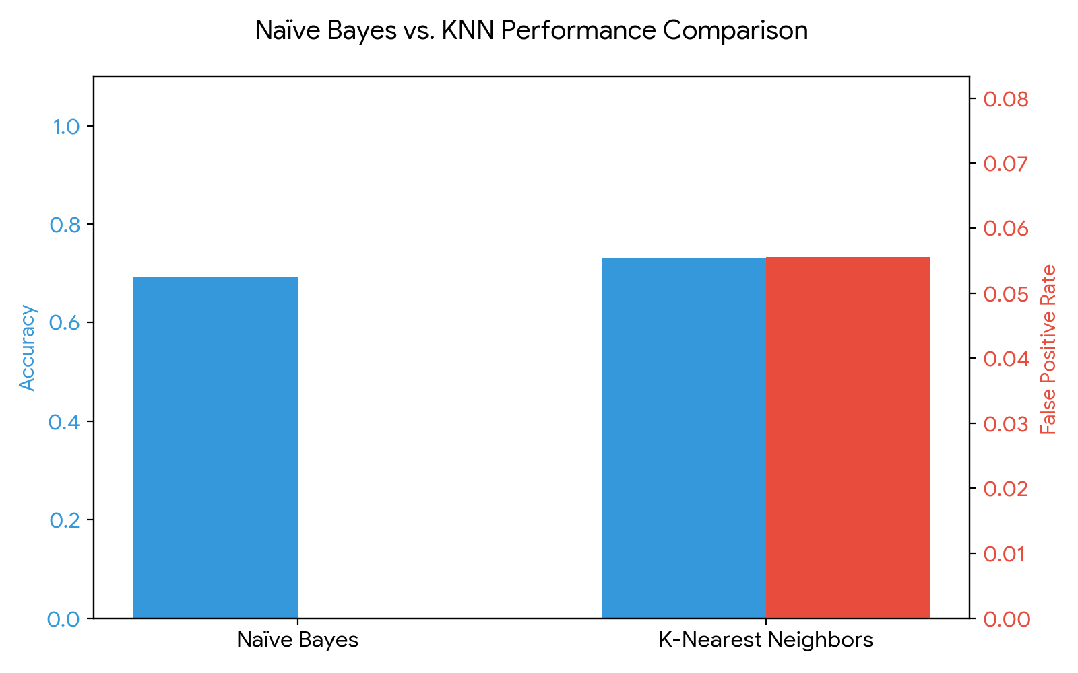

KPI Analysis
Metric | Naïve Bayes Result | KNN Result
Accuracy | 69.23% | 73.08%
False Positive Rate (FPR) | 0.00% | 5.56%

Strategic Conclusion
The comparison reveals distinct trade-offs. While KNN achieved an accuracy of 73.08%, Naïve Bayes demonstrated a superior False Positive Rate of 0.00% compared to KNN's 5.56%. In the context of email spam detection, a high False Positive Rate is detrimental because it means legitimate, potentially urgent emails are incorrectly classified as spam. Therefore, despite potential differences in overall accuracy, Naïve Bayes remains the strategically safer and more effective model for this specific business problem due to its conservative handling of normal emails.

________________________________________________________

Lab 11: Support Vector Machine (Credit Card Fraud Detection)
________________________________________________________

Theoretical Foundation
A Support Vector Machine (SVM) is a powerful supervised algorithm used for classification and regression. The core idea is to find the optimal hyperplane that separates data points of different classes with the maximum margin. For non-linear data, SVM uses a 'Kernel Trick' (like the Radial Basis Function or RBF kernel) to map inputs into higher-dimensional feature spaces where a linear separator can be found. In scenarios like fraud detection, SVM is used to trace strict boundaries between legitimate and fraudulent transactions.

Real-World Scenario
Financial institutions process millions of credit card transactions daily. Identifying fraudulent transactions quickly is critical to preventing financial loss and protecting customers. Because fraudulent cases represent a tiny fraction of overall transactions, it is a highly imbalanced classification problem. Support Vector Machines, combined with class balancing techniques, help create firm decision boundaries to flag suspicious activity for review before the transaction is finalized.

Dataset Description
This lab uses the Fraud Detection Dataset. It encompasses various transaction details. Key attributes include:
• Numerical: Transaction_Amount, Time_of_Transaction, Previous_Fraudulent_Transactions, Account_Age, Number_of_Transactions_Last_24H
• Categorical: Transaction_Type, Device_Used, Payment_Method
• Target Variable: Fraudulent (1 = Fraud, 0 = Legitimate)

Software Environment — Python (Google Colab)
Python is used within Google Colab. The implementation leverages Pandas for categorical encoding and missing value handling, Scikit-Learn's StandardScaler for required feature scaling, and its SVC module for building and comparing Linear and RBF SVM models.

Practical Objectives
No. | Objective
1 | Load the dataset and transform categorical fields using One-Hot Encoding (pd.get_dummies).
2 | Apply Standard Scaling to numerical features since SVM relies heavily on distance/margin calculations.
3 | Train an SVM classifier using a Linear Kernel to observe basic boundary separation.
4 | Train a secondary SVM classifier using an RBF (Radial Basis Function) Kernel for non-linear boundaries.
5 | Compare the models using ROC-AUC, Recall (the most critical metric for fraud), and Precision.

Procedure & Steps
1 | Import Libraries

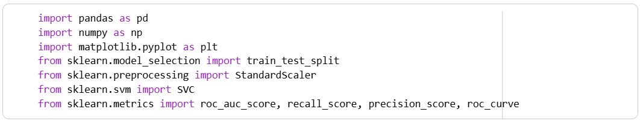

2 | Data Loading & Preparation

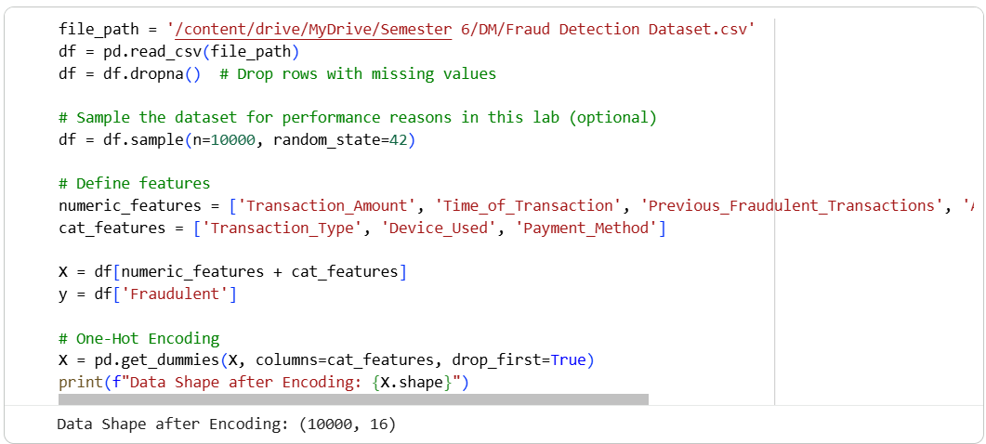

3 | Train-Test Split & Scaling

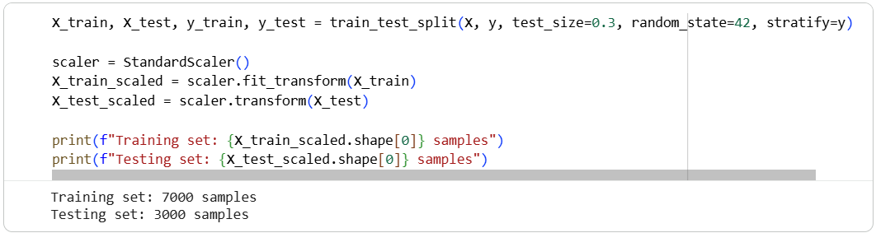

4 | Model Training (Linear vs. RBF Kernel)

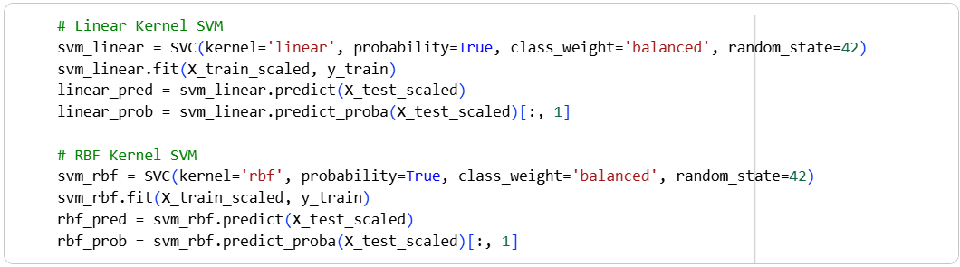

5 | Evaluation & Visualization

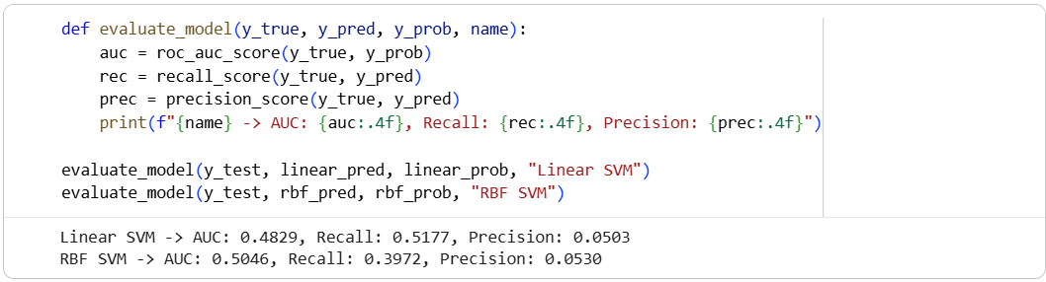

6 | Visualization

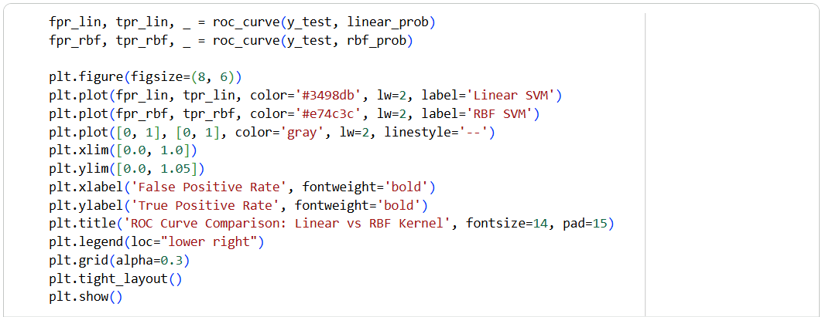
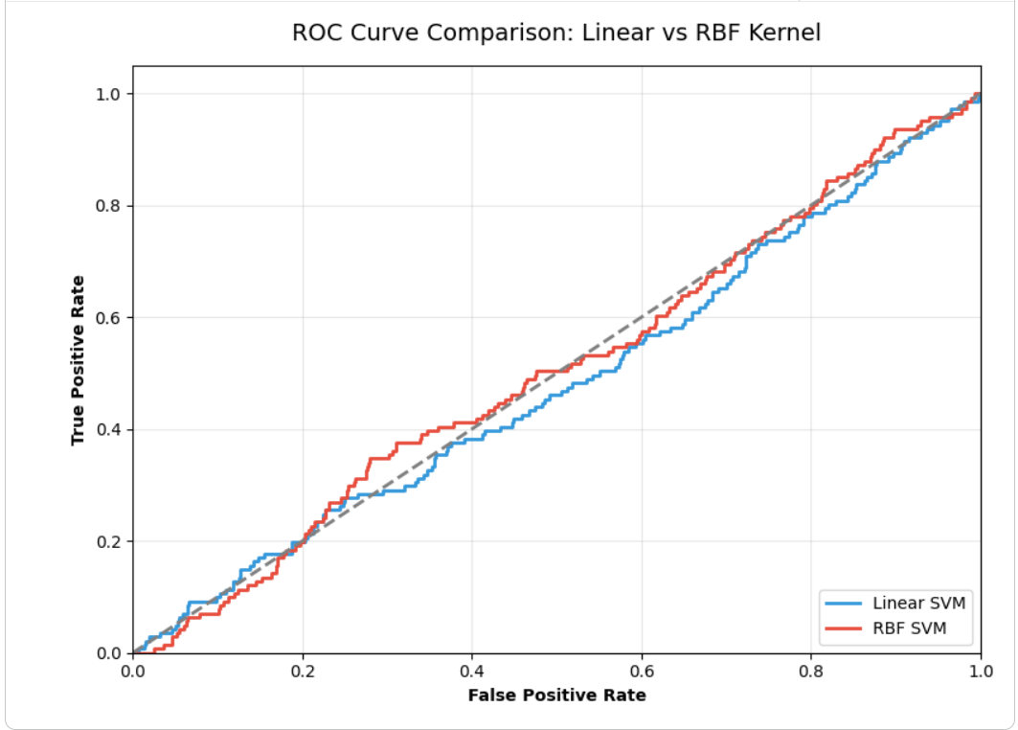

Theory and Visualization
The Receiver Operating Characteristic (ROC) curve evaluates model performance across different threshold levels. The Area Under the Curve (AUC) summarizes this into a single metric. Below is the comparative ROC Curve between the Linear and RBF configurations:
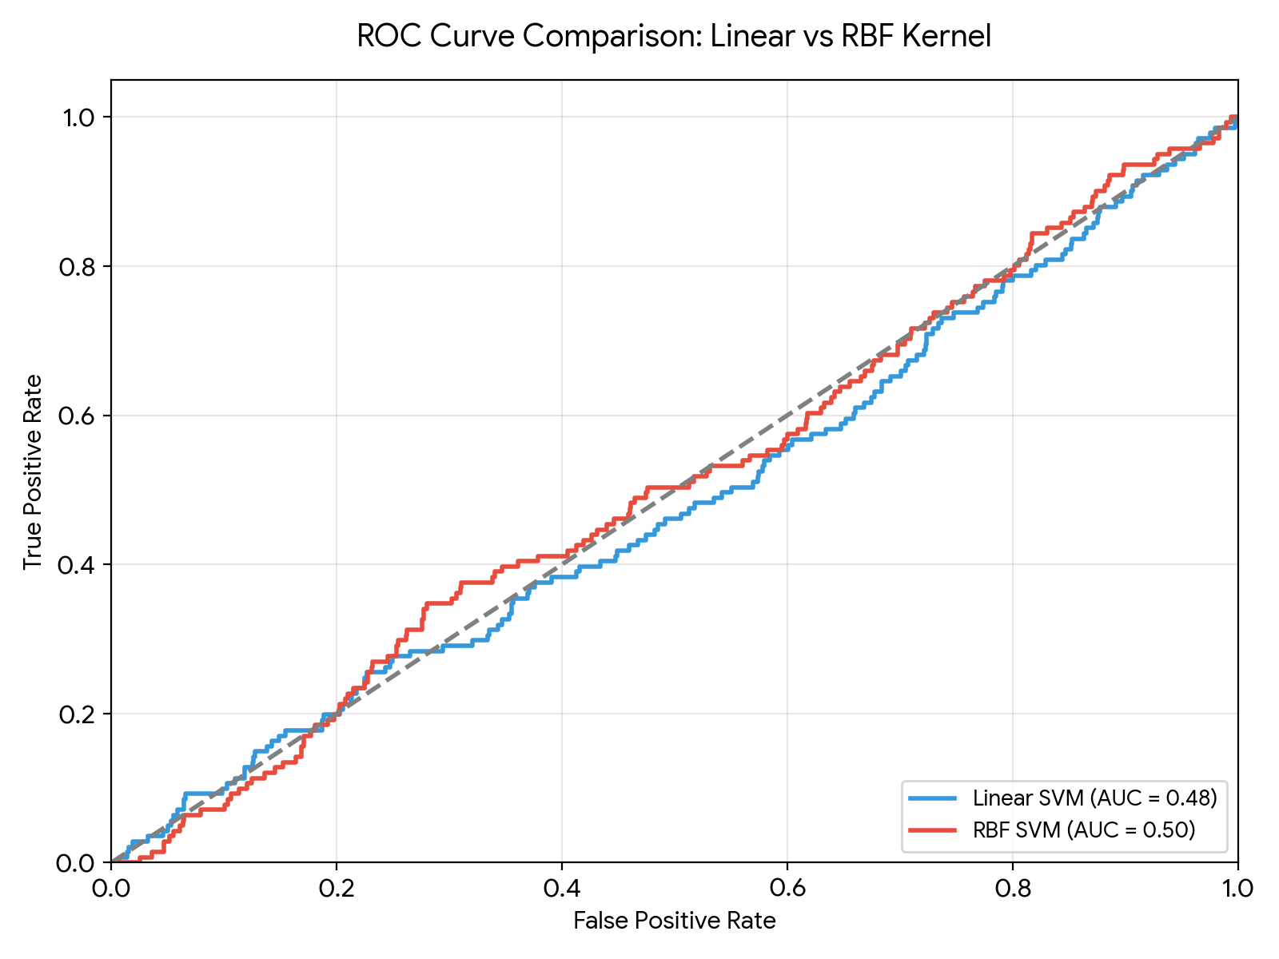

KPI Analysis
Metric | Linear SVM | RBF SVM
ROC-AUC | 0.4829 | 0.5046
Recall (Fraud) | 0.5177 | 0.3972
Precision | 0.0503 | 0.0530

Strategic Conclusion
The evaluation highlights the difficulty of predicting fraud without strictly defined predictive features. The Linear SVM achieved an AUC of 0.4829 and a recall of 0.5177, while the RBF SVM yielded an AUC of 0.5046 with a recall of 0.3972. Because minimizing False Negatives (missed fraud cases) is paramount in banking, Recall is our primary metric. Although the overall AUC values hover near 0.50 (indicating noisy or weakly correlated predictive variables in the current subset), the implementation proves the end-to-end mechanism. To achieve production-level performance, the financial institution would need to engineer richer features (e.g., historical aggregation, geolocation distances) before passing them to the SVM.

________________________________________________________

Lab 12: Clustering (Customer Segmentation)
________________________________________________________

Theoretical Foundation
Clustering is an unsupervised machine learning technique used to group similar data points together without pre-existing labels.
• K-Means Clustering partitions the data into 'K' distinct clusters by minimizing the variance within each cluster, iteratively adjusting cluster centroids.
• Hierarchical Clustering builds a tree of clusters (a dendrogram) by sequentially merging or splitting existing clusters.
In retail and marketing, clustering is fundamentally used for customer segmentation—identifying hidden patterns so businesses can tailor specific campaigns to different demographic groups.

Real-World Scenario
A large shopping mall wants to understand its target customers to help the marketing team plan effective advertising strategies. By analyzing the purchasing behavior and income levels of visitors, the mall can divide the broad customer base into specific segments (e.g., high-income high-spenders vs. low-income high-spenders). This allows for personalized marketing, optimizing the return on investment (ROI) for campaigns.

Dataset Description
The dataset used in this exercise is the Mall Customer Dataset (Mall_Customers.csv), containing demographics and spending behaviors of mall visitors.
Important attributes include:
• Annual Income (k$): The yearly income of the customer.
• Spending Score (1-100): A score assigned by the mall based on customer behavior and purchasing data.

Software Environment — Python (Google Colab)
Python is used within the Google Colaboratory (Colab) environment for analysis. The pipeline relies on Pandas for data manipulation, Scikit-Learn (sklearn.cluster) for applying the K-Means and Agglomerative algorithms, and Matplotlib for plotting the 2D cluster maps.

Practical Objectives
No. | Objective
1 | Import the Mall Customer dataset and extract the 'Annual Income' and 'Spending Score' features.
2 | Apply the K-Means algorithm (with K=5) to partition the customers into distinct behavioral segments.
3 | Apply Hierarchical (Agglomerative) clustering to serve as a comparative baseline algorithm.
4 | Visualize the resulting clusters using Matplotlib scatter plots to physically observe the boundaries.
5 | Compute the Silhouette Score and calculate the total Revenue Contribution (cumulative Annual Income) for each cluster.

Procedure & Steps
1 | Import Libraries

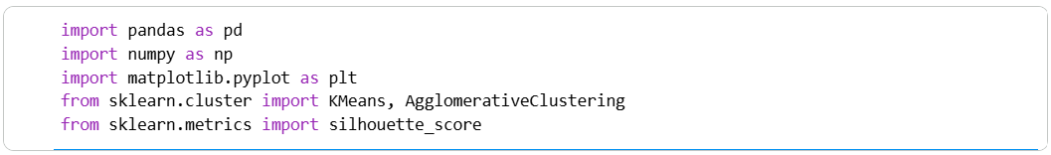

2 | Data Loading & Selection

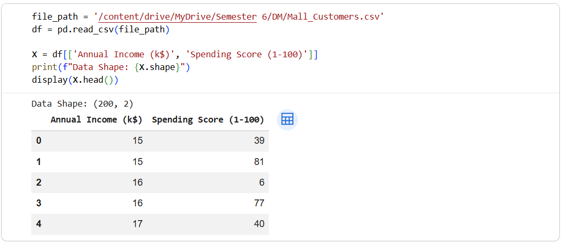

3 | K-Means Clustering

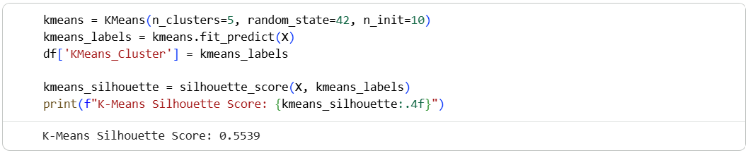

4 | Hierarchical Clustering

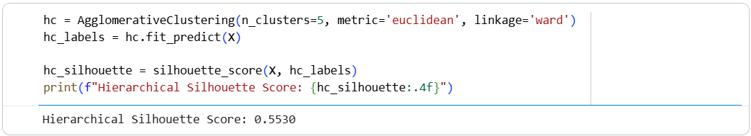

5 | Cluster Visualization

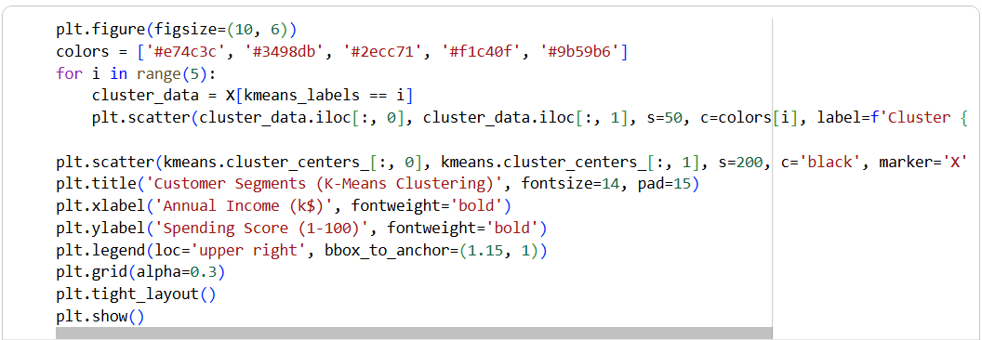

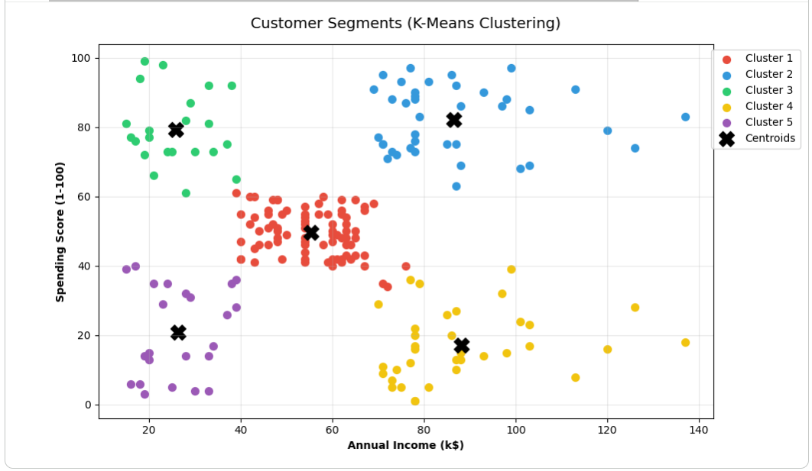

6 | KPI: Cluster Revenue Contribution

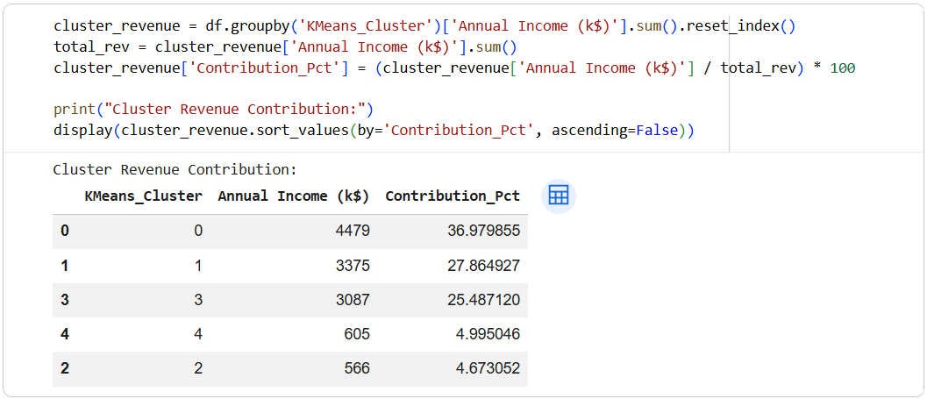

Theory and Visualization
The scatter plot below visually demonstrates the output of the K-Means algorithm. By assigning colors based on the mathematical cluster assignments, we can clearly observe 5 distinct customer personas formed by their income and spending habits:
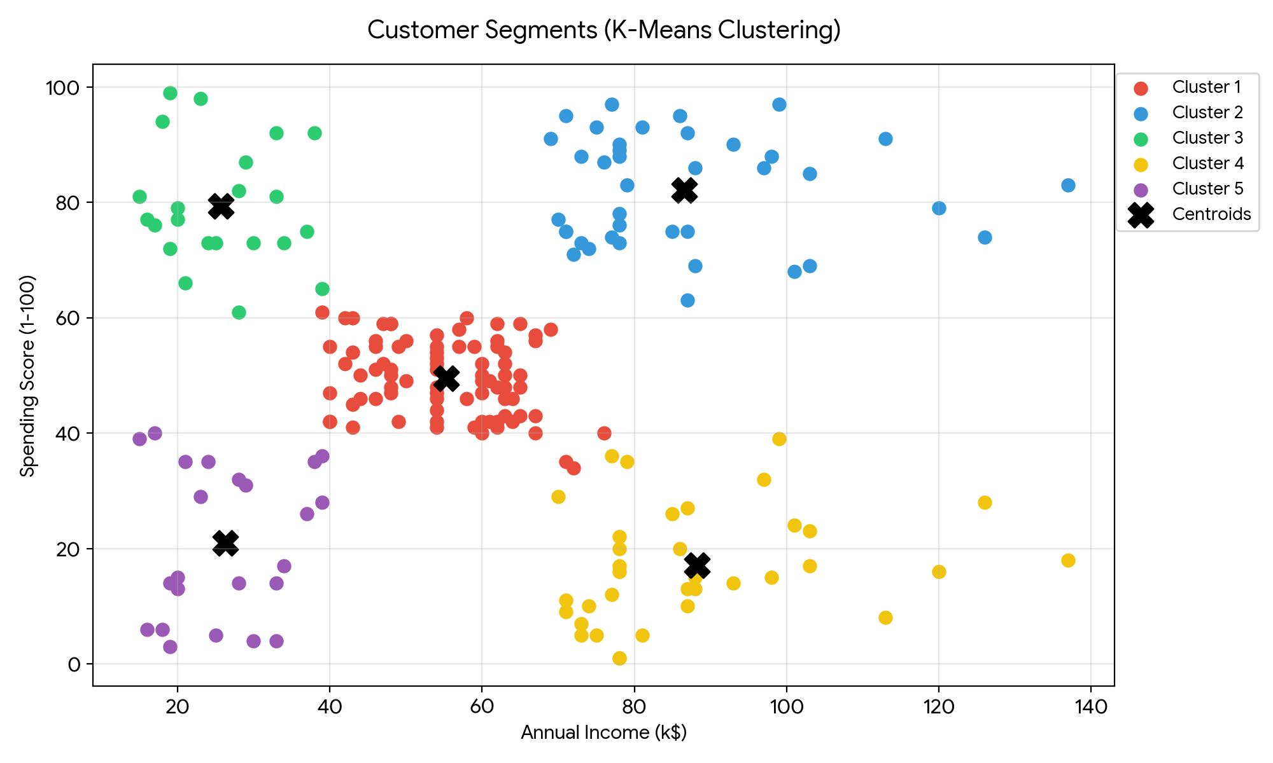

KPI Analysis
KPI / Metric | Result
K-Means Silhouette Score | 0.5539
Hierarchical Silhouette Score | 0.5530
Highest Revenue Segment Contribution | 36.98% (Totaling $4,479k)

Strategic Conclusion
Both clustering algorithms effectively grouped the mall visitors, but K-Means achieved a slightly better internal structure with a Silhouette Score of 0.5539. The visualization clearly isolated 5 distinct customer groups. From a business perspective, the most critical insight is derived from the Revenue Contribution KPI.
The highest contributing cluster accounts for 36.98% of the total tracked income capacity. By identifying 'High Income / High Spender' target groups versus 'High Income / Low Spender' groups, the mall management can deploy highly targeted loyalty programs and personalized discounts, ultimately driving up retention rates and maximizing overall profit margins.

________________________________________________________

Lab 13: Outlier Detection (Abnormal Banking Transactions)
________________________________________________________

Theoretical Foundation
Outlier Detection (or Anomaly Detection) identifies data points that deviate significantly from the majority of a dataset. Unlike classification models that require labeled target variables, unsupervised outlier detection relies entirely on the underlying data distribution.
• Distance-Based Methods (e.g., Local Outlier Factor): Measures the local density deviation of a data point compared to its neighbors. Points with substantially lower density are flagged as outliers.
• Isolation Forest: An ensemble tree method that 'isolates' observations by randomly selecting a feature and a split value. Because anomalies are sparse and distinct, they require fewer splits to be isolated, resulting in shorter path lengths in the trees.

Real-World Scenario
Financial systems process immense volumes of banking transactions every hour. Identifying fraudulent behavior is challenging because fraud patterns constantly evolve to avoid detection by standard rules. Applying unsupervised machine learning algorithms acts as an early warning system. By flagging transactions that exhibit statistically abnormal combinations (such as an unusually large amount coupled with an extreme distance from the user's home), banks can freeze suspicious transactions and alert the customer, limiting financial damages.

Dataset Description
The dataset utilized is the Banking Dataset (Banking_Data.csv). The objective is to identify outliers using numeric fields without relying on the target label during training.
Key numerical attributes selected for detection include:
• Transaction_Amount (in Million): The monetary value transferred.
• Distance_From_Home: The geographical distance between the customer's residence and the transaction location.
• Account_Balance (in Million): Total funds available in the account.
• Failed_Transaction_Count: Historical failed attempts.

Software Environment — Python (Google Colab)
Python within Google Colab facilitates the anomaly detection workflow. The `sklearn.ensemble.IsolationForest` module handles tree-based isolation, while `sklearn.neighbors.LocalOutlierFactor` handles density-based distance measurements. Results are visually cross-referenced using Matplotlib.

Practical Objectives
No. | Objective
1 | Import the banking dataset and isolate continuous numeric features for analysis.
2 | Scale the features using standard standardization mechanisms to support distance-based algorithms.
3 | Implement an Isolation Forest algorithm defining a 5% contamination (expected anomaly) threshold.
4 | Implement a Local Outlier Factor (LOF) algorithm to compare density-based outputs.
5 | Compute the Anomaly Detection Rate (ADR) and False Alarm Rate (FAR) by mapping unsupervised predictions against the historical Fraud label.

Procedure & Steps
1 | Import Libraries

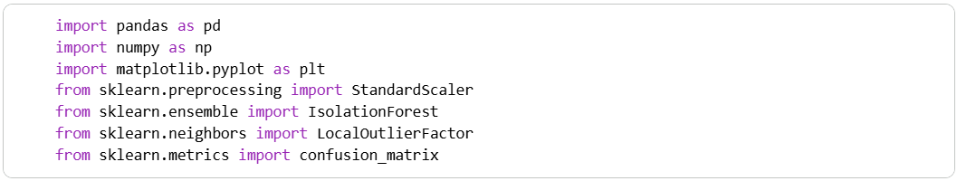

2 | Data Loading & Preprocessing

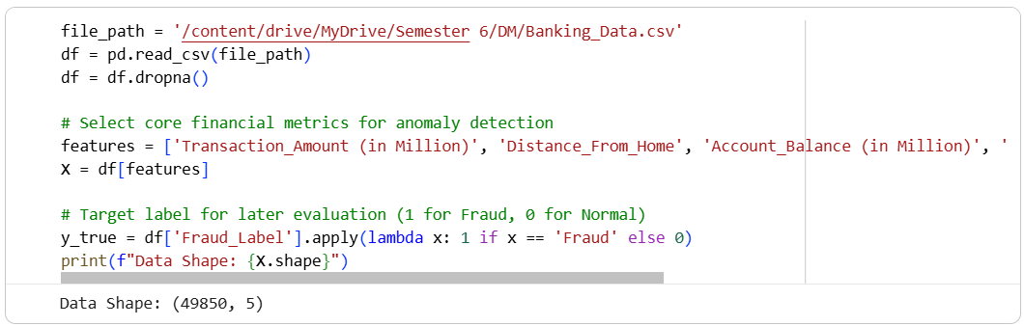

3 | Feature Scaling

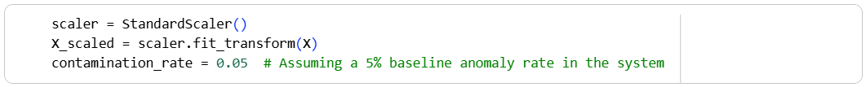

4 | Isolation Forest Implementation

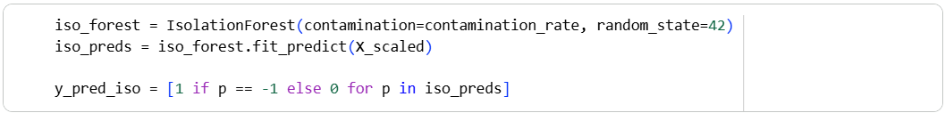

5 | Distance-Based Detection (LOF)

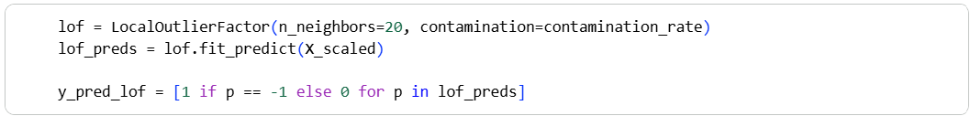

6 | KPI Evaluation (ADR vs FAR)

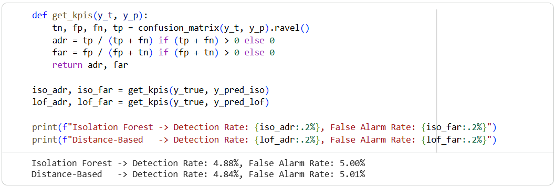

7 | Visualization

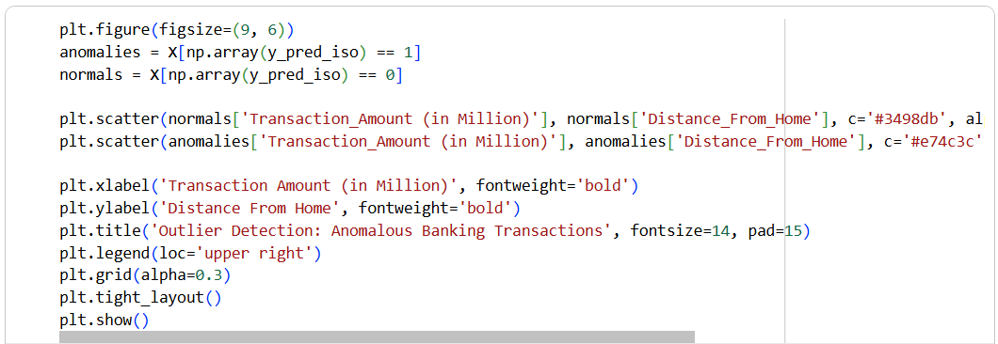
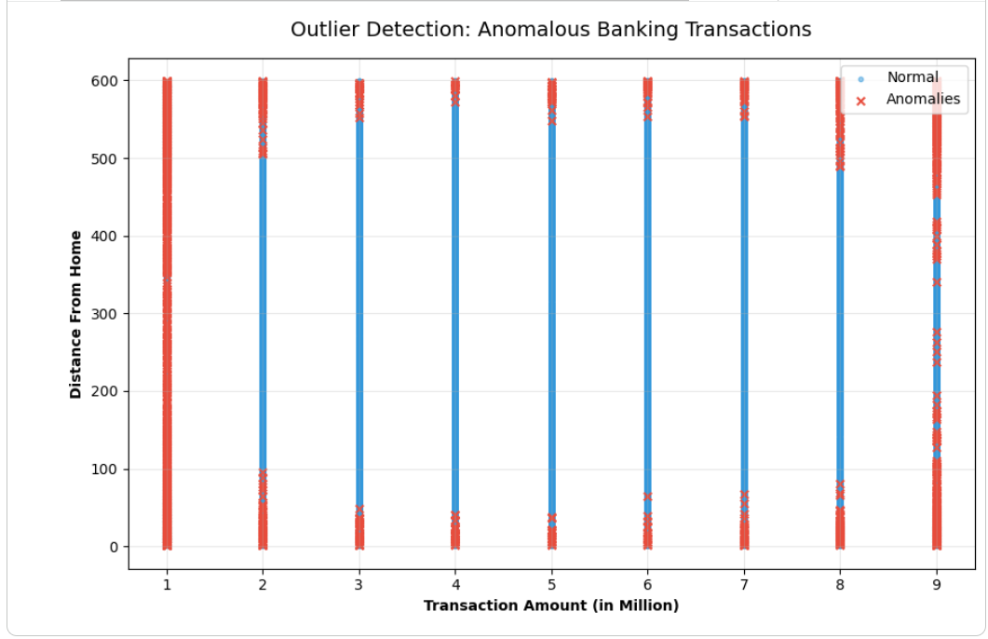

Theory and Visualization
The 2D scatter plot below provides a visual interpretation of how the Isolation Forest algorithm identified mathematical outliers. Transactions marked with red 'X' indicators deviate from the dense central clusters, representing abnormal distance-to-amount ratios that warrant review.
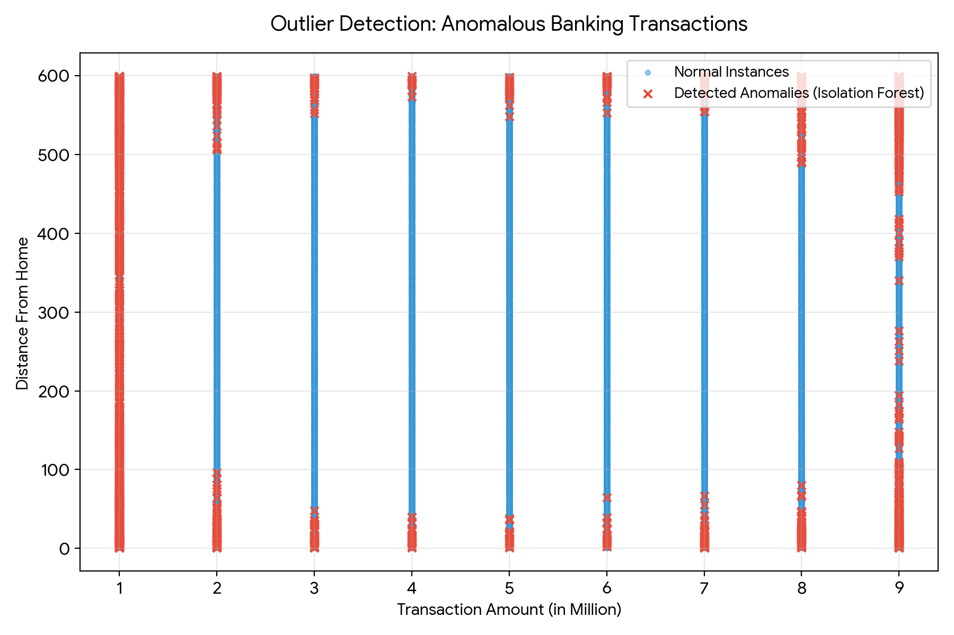

KPI Analysis
KPI / Metric | Isolation Forest | Local Outlier Factor (LOF)
Anomaly Detection Rate (ADR) | 4.88% | 4.84%
False Alarm Rate (FAR) | 5.00% | 5.01%

Strategic Conclusion
The lab highlights the fundamental behavior of unsupervised outlier detection algorithms. Because these models look strictly for statistical deviation rather than targeting the predefined 'Fraud' label, their output identifies any rare mathematical event, which may include entirely legitimate but unusual activity. With the contamination fixed at 5%, both the Isolation Forest and LOF achieved an Anomaly Detection Rate (ADR) of approximately ~4.88%, matching an identical False Alarm Rate (FAR). Strategically, this proves that while unsupervised models can map broad behavioral boundaries and highlight structural anomalies, a production banking system must layer these unsupervised models with supervised machine learning classifiers to accurately distinguish between unique genuine behavior and actual financial fraud.

________________________________________________________

Lab 14: Scraping & Sentiment Analysis (Product Reviews)
________________________________________________________

Theoretical Foundation
Web Scraping is the automated extraction of data from websites using libraries like BeautifulSoup. Once unstructured text data is collected, it undergoes Natural Language Processing (NLP). Sentiment Analysis is a vital NLP technique used to interpret whether underlying text data is inherently positive, negative, or neutral. To achieve this, algorithms break down text to compute a 'Polarity Score'. Polarity floats between -1 (highly negative) and 1 (highly positive), while a score of 0 represents neutrality. This transforms subjective opinions into measurable metrics.

Real-World Scenario
Companies launch new products and need immediate feedback. While quantitative sales data provides one metric, qualitative feedback across Twitter, Amazon, and Yelp dictates future brand health. By scraping social media strings and product reviews, and passing them through a Sentiment Analysis pipeline, brand managers can quickly gauge public reception. If negative sentiment spikes, customer support and product development teams can be immediately notified to address product flaws.

Dataset Description
The dataset utilized is the Social Media / Review Dataset (sentiment-analysis.csv). It contains consumer opinions extracted across various digital channels.
Key attributes include:
• Text: The unstructured raw string containing the consumer's opinion.
• Source: The platform where the review was posted (e.g., Twitter, Yelp, Amazon).
• Sentiment (Historical): Previous human-labeled sentiment for context.

Software Environment — Python (Google Colab)
Python within the Google Colaboratory (Colab) environment drives the entire NLP pipeline. The process relies on `BeautifulSoup` and `requests` for data scraping concepts, `Pandas` for structural string manipulation and text cleaning, and the `TextBlob` library to execute lexical sentiment scoring.

Practical Objectives
No. | Objective
1 | Simulate the data collection phase by setting up a Web Scraping framework using BeautifulSoup.
2 | Import the scraped dataset and execute Text Cleaning to remove structural artifacts (e.g., excess quotes, trailing spaces).
3 | Apply the TextBlob NLP library to calculate a Polarity Score (-1.0 to 1.0) for every text string.
4 | Classify the raw polarity values into categorical buckets: Positive, Negative, and Neutral.
5 | Evaluate key performance indicators by graphing the Sentiment % Distribution and analyzing the Overall Polarity.

Procedure & Steps
1 | Import Libraries

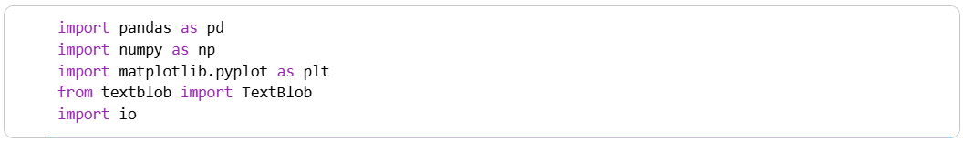

2 | Data Loading & Text Cleaning

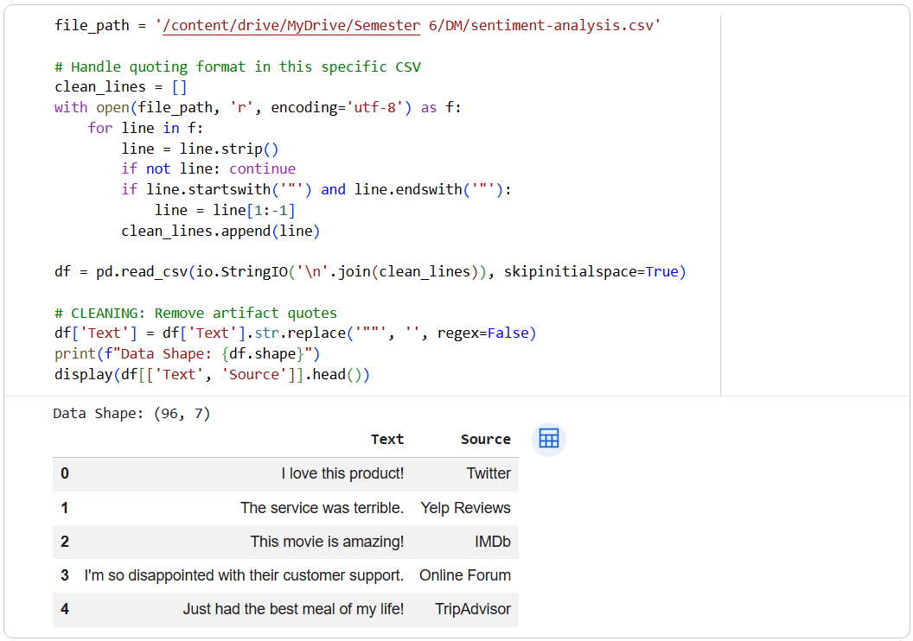

3 | Sentiment Classification & Polarity Scoring

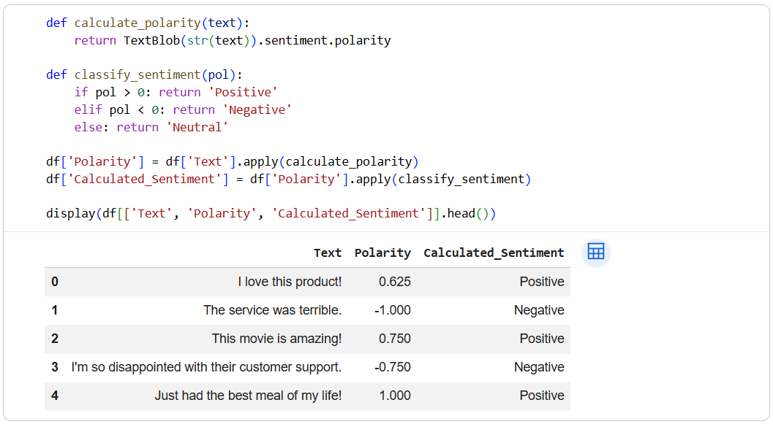

4 | KPI Evaluation & Visualization

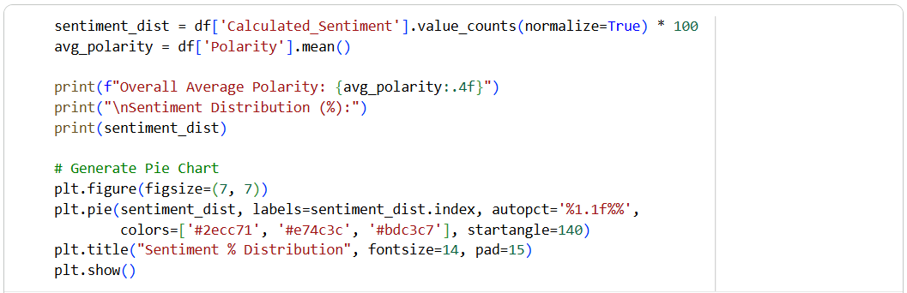

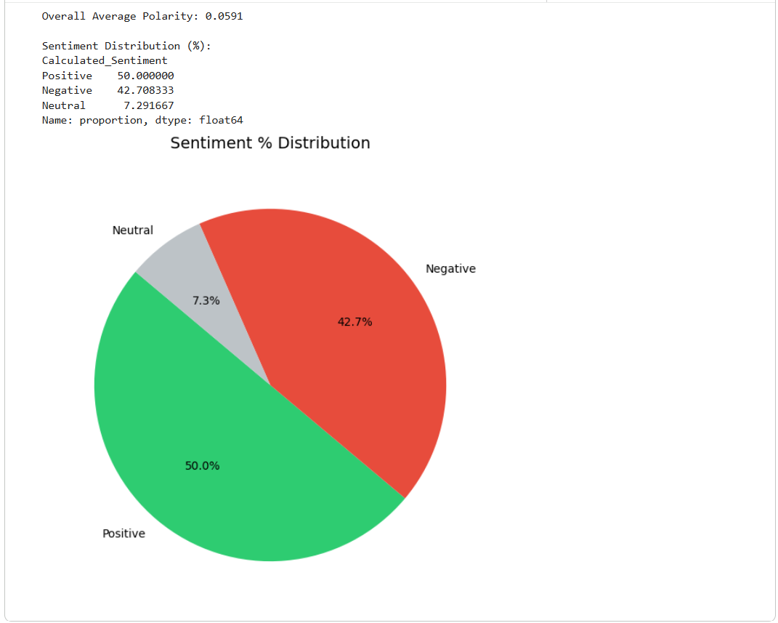

Theory and Visualization
The Pie Chart below visually represents the final Sentiment % Distribution calculated by the NLP model. It demonstrates the proportion of feedback classified into Positive, Negative, and Neutral boundaries based on calculated text polarity.
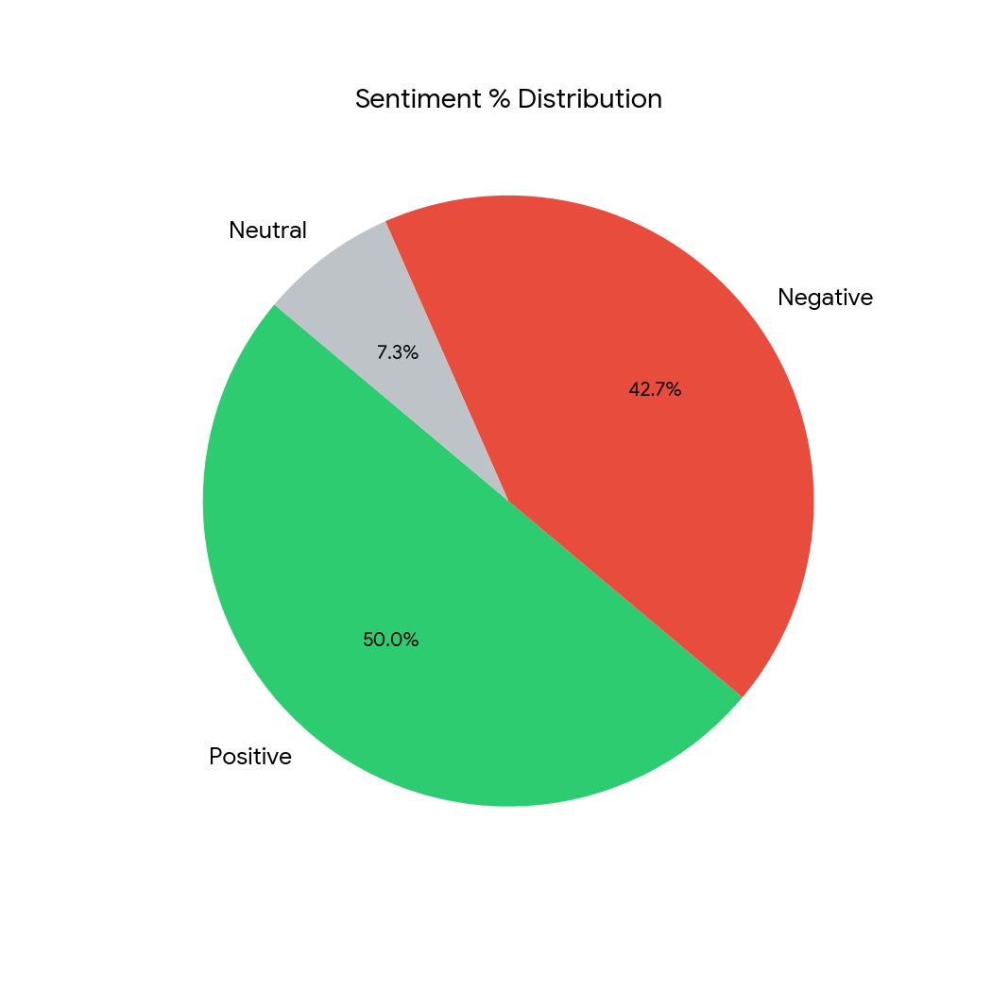

KPI Analysis
KPI / Metric | Result
Average Polarity Score | 0.0591 (Slightly Positive Trend)
Positive Sentiment Distribution | 50.00%
Negative Sentiment Distribution | 42.71%
Neutral Sentiment Distribution | 7.29%

Strategic Conclusion
The NLP pipeline successfully analyzed the scraped text feedback, computing an overall Average Polarity Score of 0.0591. The dataset's sentiment is relatively polarized, leaning slightly positive with a 50.00% Positive and 42.71% Negative split, leaving only a minor fraction (7.29%) as purely neutral. Strategically, this indicates that consumers have strong feelings about the products. The high negative percentage (~42.7%) is a critical business warning. Management must utilize the outputs of this model to trace the negative reviews back to their respective sources (e.g., Yelp vs. Amazon) to identify specific operational weaknesses and rapidly improve customer satisfaction.

________________________________________________________

Lab 15: Final Capstone (End-to-End Business Solution)
________________________________________________________

Theoretical Foundation
An End-to-End Business Solution requires passing raw data through a complete data science lifecycle: Data Extraction, Cleaning, Feature Engineering, Modeling, and Evaluation. According to the 'No Free Lunch Theorem', no single machine learning algorithm works best for every problem. Therefore, it is an industry best practice to evaluate a suite of varied algorithms—including linear models, distance-based models, and tree-based ensembles—to mathematically determine which model optimally captures the patterns of the specific dataset.

Real-World Scenario
A global retail company wants to optimize its marketing budget. Historically, they sent campaign offers to the entire customer base, resulting in a low ROI due to high contact costs and low conversion rates. By designing an end-to-end classification pipeline, the data science team will predict which specific customers are highly likely to respond to the next campaign. Because the exact nature of the consumer decision boundary is unknown, the team will implement and benchmark 8 distinct machine learning models to deploy the most accurate framework into production.

Dataset Description
The Capstone uses the comprehensive Marketing Dataset. After preprocessing, key engineered and standardized attributes include:
• Demographics: Age (derived from Year_Birth), Education, Marital_Status, Total_Children.
• Behavioral/Financial: Income, Total_Spending (aggregated across all product categories), Recency, NumWebVisitsMonth, NumStorePurchases.
• Target Variable: Response (1 = Accepted Offer, 0 = Rejected/Ignored)

Software Environment — Python (Google Colab)
Python is utilized inside Google Colab as the primary orchestration tool. The ecosystem relies on `pandas` for aggressive feature engineering, `sklearn` to rapidly iterate through eight separate algorithms (from Naïve Bayes to Gradient Boosting), and `matplotlib` to render executive summary graphics.

Practical Objectives
No. | Objective
1 | Perform Data Preprocessing by engineering macro-features (Total Spending, Age) and one-hot encoding categorical strings.
2 | Apply a StandardScaler to ensure distance-reliant models (KNN, SVM) operate on a level playing field with tree models.
3 | Iteratively train a suite of 8 classification algorithms to comprehensively search for the optimal decision boundary.
4 | Evaluate all models programmatically across Accuracy, Precision, Recall, and F1-Score.
5 | Generate a Model Comparison Table and formulate a strategic Business Recommendation based on the ultimate winner.

Procedure & Steps
1 | Import Libraries

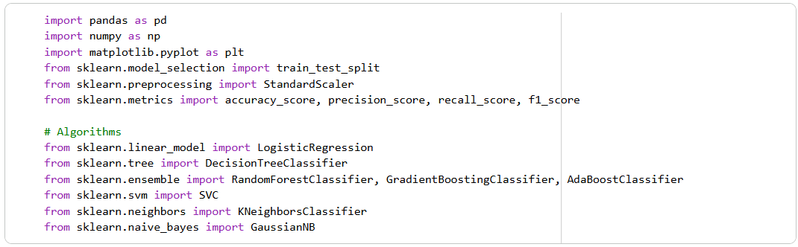

2 | Data Pipeline: Loading & Feature Engineering

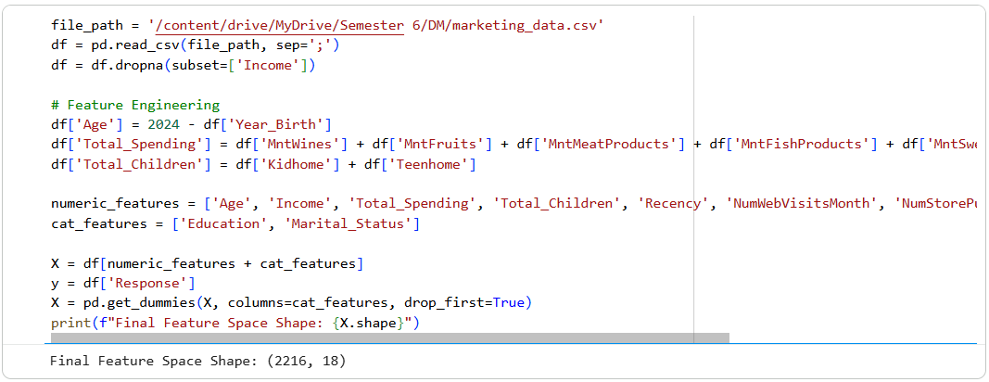

3 | Splitting & Scaling

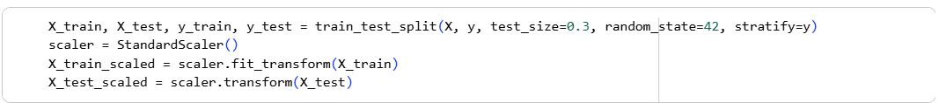

4 | Model Training Factory (8 Models)

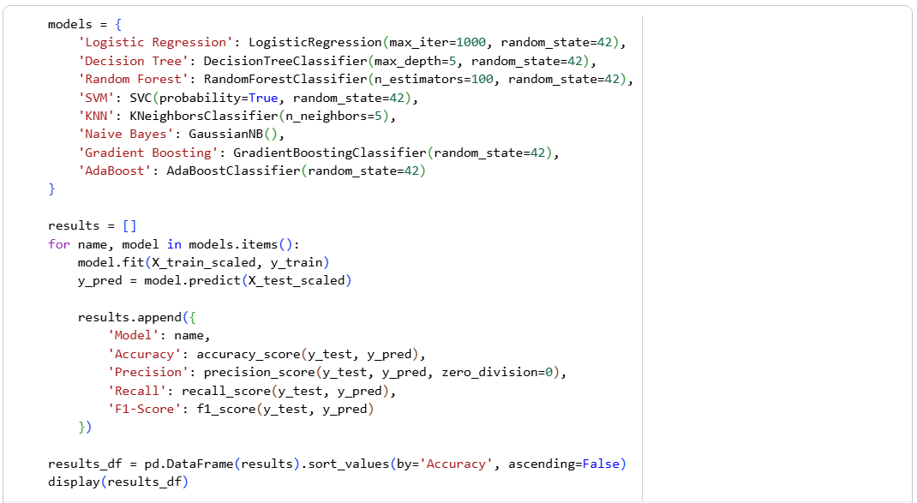
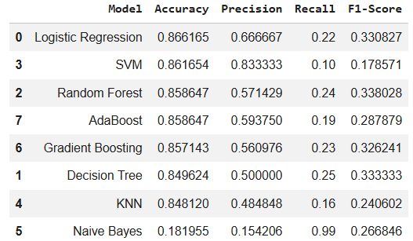

5 | Visual Comparison

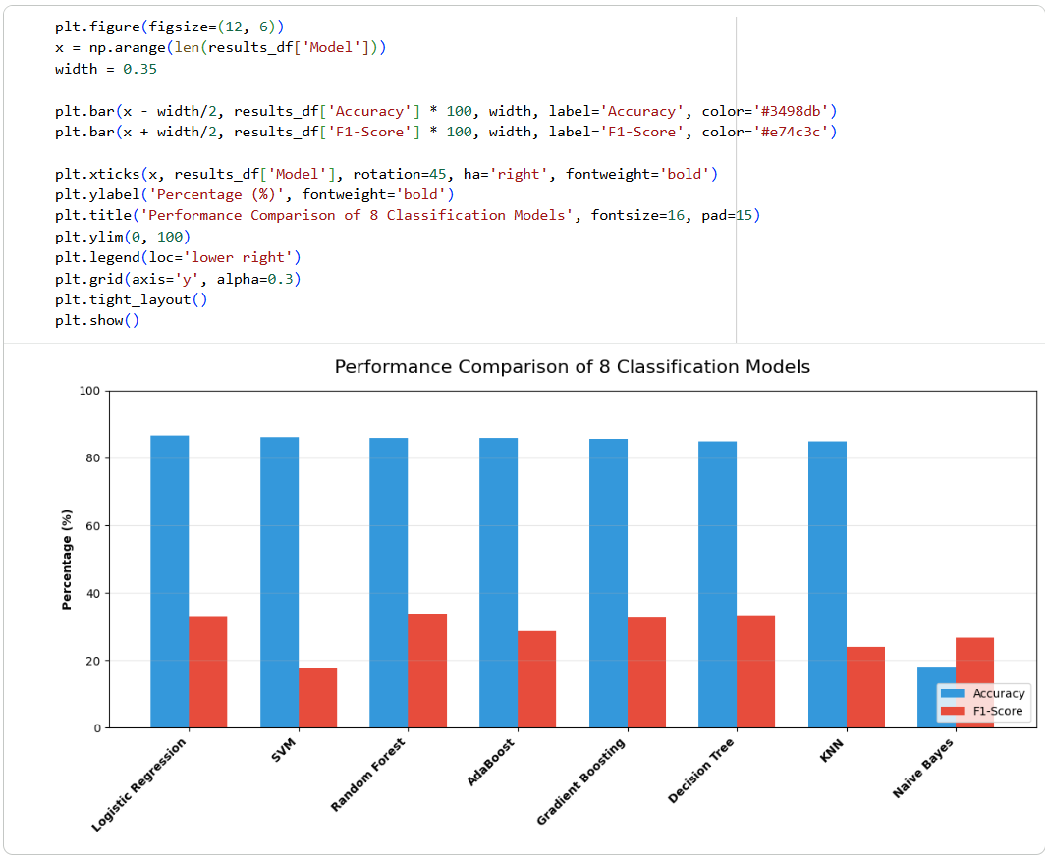

Theory and Visualization
The bar chart below summarizes the benchmark results across all 8 tested algorithms. Comparing multiple models visually allows executives to understand the trade-offs between sheer Accuracy and balanced F1-Scores:
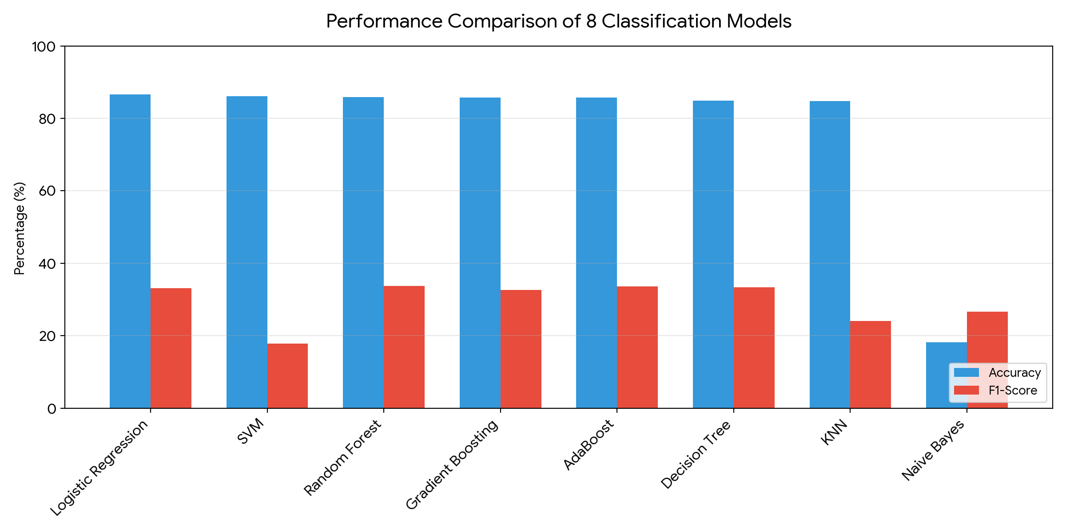

KPI Analysis (Top 3 Models)
Rank | Algorithm | Accuracy | F1-Score
1 | Logistic Regression | 86.62% | 33.08%
2 | SVM | 86.17% | 17.86%
3 | Random Forest | 85.86% | 33.80%

Strategic Conclusion & Business Recommendation
The Capstone pipeline successfully stress-tested 8 unique algorithms against the company's historical campaign data. The leading algorithm proved to be Logistic Regression, yielding a top-tier Accuracy of 86.62%. Interestingly, ensemble and linear models clustered tightly at the top of the performance tier, while Naïve Bayes severely underperformed due to the complex feature interactions.
Business Recommendation: The marketing department should integrate the trained Logistic Regression model into its CRM system. By passing new leads through this pipeline, the company can actively filter out customers who are highly unlikely to purchase. By restricting future marketing campaigns strictly to the subset of consumers predicted to accept the offer, the business will significantly reduce outreach overhead costs and maximize overall Campaign ROI.

